

S.No Contents Page No.

1. Project Abstract
2. Organization Profile
3. Cost Estimation
4. Effort Estimation
5. SRS
5.1 Introduction

5.1.1 Purpose
5.1.2 Scope
5.1.3 Definition, Acronyms and Abbreviations
5.1.4 References
5.1.5 Software Development Methodology

5.2 System Analysis

5.2.1 Study of the Existing system
5.2.2 Problem in Existing System
5.2.3 Proposed System
5.2.4 Requirement Specification

5.2.4.1 Functional Requirements
5.2.4.1 Non-Functional Requirements

5.3 Feasibility Study

5.3.1 Operational Feasibility
5.3.2 Technical Feasibility
5.3.3 Economical Feasibility

5.4 System Requirement Study

5.4.1 Software Requirements
5.4.2 Hardware Requirements

5.5 User Requirement Document (URD)

5.5.1 Use Case Diagram
5.5.2 Look up Table
5.5.3 Use Case Documentation
5.5.4 Activity Diagram

5.5 System Design

5.5.1 System Feature & Sequence Diagram
5.5.2 Collaboration Diagram
5.5.3 Data Dictionary

5.5.3.1 ER Diagrams
5.5.3.2 Table Structure
5.5.4 Class Diagram
5.5.5 User Interface Design

- Coding
  - Coding Standards & Guidelines
  - Technology Notes
    - Front End
    - Back End
    - Other Tools
- Testing and Implementation
  - Test Case Description
  - Result Table
- Conclusion
- Future Enhancements
- Bibliography

Project Abstract

This system deals with automation of Employee recruitment and induction process. The overall recruitment process is automated since the time the candidate resume is submitted till he is taken on the payrolls of the enterprise. It covers all the mandatory work flows including resume processing, interview scheduling, document submission etc. The functional requirements are specified below.

E-induction Saves time, reduce costs and improve quality with e-learning. For large segments of the economy there remains an ongoing requirement to attract, recruit and retain staff. However, there is increased pressure to make this process more efficient and effective. It is more important than ever to ensure that new and existing staffs are up to speed and fully productive in as short a time as possible. So how do you save time, reduce costs and improve quality of inductions all at the same time?

Where induction training is provided, it is often delivered in highly compressed classroom formats with little opportunity for staff to fully remember and practice new knowledge and skills in preparation for use in their job role. Not only that, with even more pressure on existing staff, finding the time to provide adequate support to new employees becomes increasingly difficult.

It should come as no surprise then to learn that 90 per cent of employees decide whether to leave their new employer within the first six months (recently voiced by Gretchen Alarcon at Oracle). When staff leave early, all investment made is lost.

Using technology to support the timely delivery of core induction training answers many of the traditional problems described above. A well designed e-learning experience that covers key topic areas - company values, organizational structure, core product knowledge, health and safety for example - can engage and inform employees. And engage them at a time that suits them, all presented in a consistent and persistent manner.

Staff can also review and refer back to the e-learning as required, thus providing immediate remedial support and improving long term recall. New joiners are more self-reliant and do not need to interrupt colleagues for help on the basics. Managers and colleagues are liberated to provide essential coaching and localized support.
Some organizations are going further by using learning technology to support the recruitment and pre-joining phases of new starters. Not only can e-learning be used to test and assess applicants, providing a highly efficient filtering mechanism, it can also capitalize on the early enthusiasm and motivation of new starters from the moment they receive their Welcome Letter.

Implementing e-induction - top tips to get new recruits up-to-speed faster

To get started, try looking at your current induction practices and explore how you can implement the following:
- Measure the time it takes for a new joiner to be recruited, start and then reach full productivity in their role. Then measure the associated costs, including salary, training costs, potential lost sales etc
- Develop an Introduction/Welcome e-learning module for your organization. Representing your brand and culture, this can cover your mission, values, organizational structure, products and services. Your employees will have something of quality to engage with immediately they start
- Identify regulatory training and deliver this using e-learning that also tracks and records completion - this will save time and provide a compliance tool for all employees going forward
- Launch a pre-induction portal to support the selection process and also to enable new joiners to complete elements of their induction before Day One.
With these facilities in place, measure the time it now takes for new joiners to reach full productivity.

ORGANIZATION PROFILE:

i²labs was established in the year 2007 with an objective to provide total solutions in computer software, hardware, networking, IT and business consulting services. Presently our offices are located in Toronto (ON, Canada) and Hyderabad (AP, India). Thanks to the entrepreneurial vision, methodical planning and supportive leadership styles, the company has maintained a steady growth and expanded its business scope incorporating latest technologies and market trends to fulfill the needs of the most demanding clients. i²labs is a clique of young and dynamic professionals with many years of IT and business experience to cater to the requirements of the clients in North America, Middle East and India. i²labs ensures to provide clients with a blend of big firm expertise and a small firm attention.
Our team of techies and consultants has huge experience in evaluating, selecting, implementing and supporting software systems, project

Management and business process outsourcing. i²labs consultants have deep skill sets in a broad range of system methodology disciplines coupled with best of breed expertise and problem solving savvy to help deliver and integrate solutions to your unique business challenges.
What we do?

i²labs provides various services within the information technology field. From staff recruiting and training, business and IT consulting, software
development and implementation to business process outsourcing, i²labs provides the best solutions for most demanding clients maintaining high quality standards.
We visualize our success as factor dependent on our customers' satisfaction. Our solutions help our customers reduce costs, lower risks and grow revenues. Our goal is to help our customers achieve a competitive advantage by providing solutions that return superior business results.

IT Consulting.
Business Process Analysis.
EAI Implementation.
Software Training & support.
On-site and in-house software development.

We provide a full range of consulting services ranging from a professional assessment of your current information systems to a detailed evaluation of your existing business processes to determine how information technologies can be used to streamline your operations. We are uniquely positioned to be able to evaluate your business processes and recommend best solutions to help you work more efficiently and effectively.
Whether its business analysts, project leaders, or software and hardware technicians, i²labs Consulting Services provide highly experienced consultants
that assist in managing projects or augmenting a project team in a best possible manner.
i²labs Consulting delivers Internet solutions designed to improve clients' business processes including, strategy consulting, analysis and design, technology development, systems implementation, and systems integration.
The Company's solutions target a client's specific business functions, enabling the linkage of people, processes, and technologies in the new digital economy.
Staff Recruitment and Training
Recruiting qualified technology staff is a time consuming and resource intensive affair. I2labs serves as an outside personnel department to make your recruitment process easier. With a growing IT talent shortage, many companies find it difficult to hire enough.

COST AND EFFORT ESTIMATION:

FUNCTION POINT MODEL
It is based on the visible features of the system that are weighed accordingly to produce an overall score. The intent is to construct a measure of product size that can be available easily in the development process. It is based on the notion of function points regarding as a measure of functionality of the system. The starting point of the construction of the model is to determine the number of items occurring in the system.
The items are as follows:
External inputs are the inputs from the user that provide distinct application oriented data. Examples of such inputs are filenames and menu selections.
External outputs are directed to the user, they come in the form of various reports and messages.
User inquiries are interactive inputs requiring the response.
External files deal with all machine readable interfaces on other systems.
Internal files are the master files in the system.
These items are related differently according to their complexity that is given below in the following table.
Item | Simple | Average | Complex
External Inputs | 3 | 4 | 6
External Outputs | 4 | 5 | 7
User Inquiries | 3 | 4 | 6
External files | 7 | 10 | 15
Internal files | 5 | 7 | 10

Here, first the Unadjusted Function Count (UFC) is determined using the formula
UFC = ∑itemi wi
In the second phase, refining the Function Point Count by including Technical Complexity Factor (TCF) and multiplying the value with UFC by using the formula determine Adjusted Function Point Count (FP):
FP = UFC * TCF
Where TCF is calculated using the formula:
TCF = 0.65 + 0.1∑fi
Where if specifies the detailed factors contributing to the overall notion of complexity.
The various factors are as follows-
- Reliable Backup and Recovery
- Distributed Functions
- Heavily used Configuration
- Operational Use
- Complex Interface
- Reusability
- Multiple sites
- Data Communications
- Performance
- Online Data Entry
- Online Update
- Complex Processing
- Installation Ease
- Facilitate Change
Here each factor is rated on 0 to 5 scales with 0 being irrelevant and 5 standing for essential. If al the factors are irrelevant then the constant 0.65 is used otherwise the constant 1.35 is used.

Considering the Data Automation System the items are as follows-
External inputs – 37 (File no, Mineral Id, Mineral Name, Land Type, Location, GO number, Year of join, Exp Year, Area, . . .)
External outputs – 3 (Confirmation to Dorector, Confirmation to Data Entry Clerk, Test report)
User inquiries – 5 (Availability of location, Validity of client, Selecting mine site, .....)
External Files – (Client info files)
Internal Files – 7 (Minerals & User’s info files)
Considering the Data Automation System, we assume the complexity of all items to be average.
So, UFC = (4*37) + (5*3) + (4*5) + (10*1) + (7*7)
= 148 + 15 + 20 + 10 + 49
=182
TCF = 0.65 + 0.1(5 + 0 + 0 + 5 + 1 + 1 + 0 + 3 + 0 + 0 + 1 + 2)
= 2.45
Therefore FP = UFC*TCF
= 182*2.45
= 445.9

Software Recruitment Specification

Introduction:

This project tells about Maintains the recruitment process of the organization and each and every employee details of a software organization. Especially this is all about how the Company maintains the details of all recruitment process from applicant resume received to till he registered in organizational payroll department as an employee.

Purpose:

It is internal project of a software company developed for the sake of HR to maintain all the recruitment details and also to get required reports of employees and applicants on various categories who are working in various branches of same Organization

Scope:

Definition, Acronyms and Abbreviations

Term | Definition
EIS | E-Induction System
UC | Use case
NA | Not Applicable
URD | Use case Requirement Document
BRD | Business Requirement Document

References:

Software Development Methodology:

Research and Development

Once the Market Research is carried out, the customer's need is given to the Research & Development division (R&D) to conceptualize a cost-effective system that could potentially solve the customer's needs in a manner that is better than the one adopted by the competitors at present. Once the conceptual system is developed and tested in a hypothetical environment, the development team takes control of it. The development team adopts one of the software development methodologies that is given below, develops the proposed system, and gives it to the customer.

The Sales & Marketing division starts selling the software to the available customers and simultaneously works to develop a niche segment that could potentially buy the software. In addition, the division also passes the feedback from the customers to the developers and the R&D division to make possible value additions to the product.

While developing a software, the company outsources the non-core activities to other companies who specialize in those activities. This accelerates the software development process largely. Some companies work on tie-ups to bring out a highly matured product in a short period.

Popular Software Development Models
The following are some basic popular models that are adopted by many software development firms
A. System Development Life Cycle (SDLC) Model

B. Prototyping Model

C. Rapid Application Development Model

D. Component Assembly Model

A. System Development Life Cycle (SDLC) Model

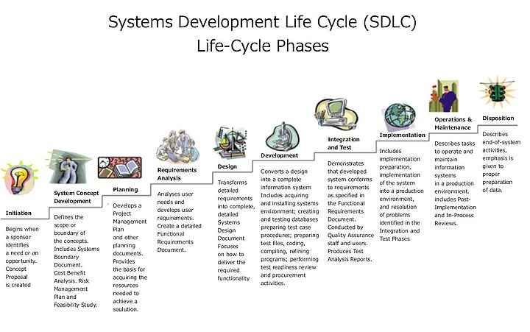
This is also known as Classic Life Cycle Model (or) Linear Sequential Model (or) Waterfall Method. This model has the following activities.

1. System/Information Engineering and Modeling
As software is always of a large system (or business), work begins by establishing the requirements for all system elements and then allocating some subset of these requirements to software. This system view is essential when the software must interface with other elements such as hardware, people and other resources. System is the basic and very critical requirement for the existence of software in any entity. So if the system is not in place, the system should be engineered and put in place. In some cases, to extract the maximum output, the system should be re-engineered and spruced up. Once the ideal system is engineered or tuned, the development team studies the software requirement for the system.

2. Software Requirement Analysis
This process is also known as feasibility study. In this phase, the development team visits the customer and studies their system. They investigate the need for possible software automation in the given system. By the end of the feasibility study, the team furnishes a document that holds the different specific recommendations for the candidate system. It also includes the personnel assignments, costs, project schedule, target dates etc.... The requirement gathering process is intensified and focussed specially on software. To understand the nature of the program(s) to be built, the system engineer or "Analyst" must understand the information domain for the software, as well as required function, behavior, performance and interfacing. The essential purpose of this phase is to find the need and to define the problem that needs to be solved .

3. System Analysis and Design
In this phase, the software development process, the software's overall structure and its nuances are defined. In terms of the client/server technology, the number of tiers needed for the package architecture, the database design, the data structure design etc... are all defined in this phase. A software development model is thus created. Analysis and Design are very crucial in the whole development cycle. Any glitch in the design phase could be very expensive to solve in the later stage of the software development. Much care is taken during this phase. The logical system of the product is developed in this phase.

4. Code Generation
The design must be translated into a machine-readable form. The code generation step performs this task. If the design is performed in a detailed manner, code generation can be accomplished without much complication. Programming tools like compilers, interpreters, debuggers etc... are used to generate the code. Different high level programming languages like C, C++, Pascal, Java are used for coding. With respect to the type of application, the right programming language is chosen.

5. Testing

Once the code is generated, the software program testing begins. Different testing methodologies are available to unravel the bugs that were committed during the previous phases. Different testing tools and methodologies are already available. Some companies build their own testing tools that are tailor made for their own development operations.

6. Maintenance
The software will definitely undergo change once it is delivered to the customer. There can be many reasons for this change to occur. Change could happen because of some unexpected input values into the system. In addition, the changes in the system could directly affect the software operations. The software should be developed to accommodate changes that could happen during the post implementation period.

System Analysis

Study of the system

The aim of the project is to develop interactive application for the staff recruitment in an organization. The manual process of recruitment system is very complex to handle. And employee specially has to work out for this. Then there is waste of time of the employee and cost effective to maintain all the interview process.

The aim of this project is to develop a graphical user interface this can be easily understood by the end users also. Through this we are developing a dynamic application that enable the select and recruit of employee to an enterprise. By this application we can reduce the work effectiveness of organization employees.

There is graphical user interface is developed to interact with the perspective employee and existed employees. Through this every one can interact with the organization databases.

New user understandable formats are inserted into application.
Through these contents users are interacting and applying to the organizations to become an employee.

The main goal of this system is to develop an application that helps reduce the manual work of organization employee for recruitment. The applicant is interacting with automated system developed for the company. There maximum reduction of manual processing is achieved through this system.

Problems in Existing system

In Existing System the Hr Manager is completely depending on the manual process for generating the records etc. Things like maintaining the details of the Interview Schedule and Provided the Interview timings to the Selected Candidates etc.., are done by record keeping.
In Existing system there is a manual work to recruit a candidate. The manager has to maintain records about the employee and etc. So there time waste for employee. And maintaining of records on papers or not safe for long life. These problems arises the development of automated system recruitment process.

Proposed System

The Proposed system has the following features like generating any number of reports; define to post the Vacancies in the Company etc. More over it will schedule to Monitor employee Resumes and their Details for reconciliation and it includes the features like quickly retrieve historical data, List of Applicants based on Requirements and mange flexible interview Schedule for Selected Candidates, Track vacation and so on.
Proposed system include automated systems, the applicant interact with the organization through the automated system. Perspective employee post his resume against selected job and receives the interview schedule.
Except the interview modules of Interview interaction and HR round interaction everything in the system is designed as automated generation of reports and others.

Requirement Specification:

Functional Requirements:

- The system should have provision for the HR coordinator to post the vacancies/openings against required positions in the enterprise.
- The system should allow the employees/consultancies to submit candidates resume against the posted positions.
- System should provide options to the HR coordinator to monitor and filter the received resume and process them based on the requirements.
- System should have the provision to communicate (through email) with the selected candidates regarding the interview schedule etc.
- System should provide the provision to HR representative to configure the interview schedule based on the interviewer availability.
- System should provide the option for the interviewer to upload the interview feedback/result into the database for further processing.
- System should provide the option to the HR representative to generate the Offer Letter for the selected candidates.
- The selected candidates should be provided with temporary user id and password to access the system and upload their past experience and educational certificates for background verification check.

Non-Functional Requirements:

- The users of the system should be provided user id and password along with the well defined access privileges.
- 24X7 internet connectivity should be provided for well functioning of the system.
- Systems should be provided with proper backup media and resources to handle system crash scenarios.

FEASIABILITY STUDY

Feasibility Study:

Preliminary investigation examines project feasibility; the likelihood the system will be useful to the organization. The main objective of the feasibility study is to test the Technical, Operational and Economical feasibility for adding new modules and debugging old running system. All systems are feasible if they are given unlimited resources and infinite time. There are aspects in the feasibility study portion of the preliminary investigation:

- Technical Feasibility
- Operation Feasibility
- Economical Feasibility

TECHNICAL FEASIBILITY:

Evaluating the technical feasibility is the trickiest part of a feasibility study. This is because, at this point in time, not too many detailed design of the system, making it difficult to access issues like performance, costs on (on account of the kind of technology to be deployed) etc. A number of issues have to be considered while doing a technical analysis.

Understand the different technologies involved in the proposed system:
Before commencing the project, we have to be very clear about what are the technologies that are to be required for the development of the new system.

Find out whether the organization currently possesses the required technologies:
Is the required technology available with the organization?
If so is the capacity sufficient?

For instance- “Will the current printer be able to handle the new reports and forms required fort the new system?”

  - The technical issue usually raised during the feasibility stage of the investigation includes the following:

  - Does the necessary technology exist to do what is suggested?

  - Do the proposed equipments have the technical capacity to hold the data required to use the new system?

  - Will the proposed system provide adequate response to inquiries, regardless of the number or location of users?

  - Can the system be upgraded if developed?

OPERATIONAL FEASIBILITY

Proposed projects are beneficial only if they can be turned into information systems that will meet the organizations operating requirements. Simply stated, this test of feasibility asks if the system will work when it is developed and installed. Are there major barriers to implementation? Here are questions that will help test the operational feasibility of a project.

Is there sufficient support for the project from management from users? If the current system is well liked and used to the extent that persons will not be able to see reasons for change, there may be resistance.

Are the current business methods acceptable to the user? If they are not, Users may welcome a change that will bring about a more operational and useful systems.

Have the user been involved in the planning and development of the project? Early involvement reduces the chances of resistance to the system and in general and increases the likelihood of successful project.

Since the proposed system was to help reduce the hardships encountered. In the existing manual system, the new system was considered to be operational feasible.

User-friendly
Customer will use the forms for their various transactions i.e. for adding new routes, viewing the routes details. Also the Customer wants the reports to view the various transactions based on the constraints. Theses forms and reports are generated as user-friendly to the Client.

Reliability
The package wills pick-up current transactions on line. Regarding the old transactions, User will enter them in to the system.

Security
The web server and database server should be protected from hacking, virus etc

Portability
The application will be developed using standard open source software (Except Oracle) like Java, tomcat web server, Internet Explorer Browser etc these software will work both on Windows and Linux o/s. Hence portability problems will not arise.

Maintainability

The system called the ewheelz uses the 2-tier architecture. The 1st tier is the GUI, which is said to be front-end and the 2nd tier is the database, which uses My-Sql, which is the back-end.

The front-end can be run on different systems (clients). The database will be running at the server. Users access these forms by using the user-ids and the passwords.

ECONOMIC FEASIBILITY:
Economic feasibility attempts to weights the costs of developing and implementing a new system, against the benefits that would accrue from having the new system in place. This feasibility study gives the top management the economic justification for the new system.

A simple economic analysis which gives the actual comparison of costs and benefits are much more meaningful in this case. In addition this provides to be a useful point of reference to compare actual costs as the project progresses. There could include increased client satisfaction, improvement in product quality better decision making timeliness of information, expediting activities, improved accuracy of operations, better documentation and record keeping, faster retrieval of information, better employee morale.

The computerized system takes care of the present existing system’s data flow and procedures completely and should generate all the reports of the manual system besides a host of other management reports.
It should be built as a web based application with separate web server and database server. This is required as the activities are spread through out the organization customer wants a centralized database. Further some of the linked transactions take place in different locations.

Open source software like .Net, JAVA, Mysql and Linux is used to minimize the cost for the Customer.

Environmental Details

Software:

Technology : ASP.NET with Ajax
Programming Language : C#.NET
Database : SQL Server.
Modeling Language : Rational Rose (UML).
Application Server : IIS (Internet Information Server)

Hardware:

- Pentium IV processor
- 1 GB RAM
- 80GB HDD

URD (USER REQUIREMENT DOCUMENT)

Use Case Diagrams

Perspective Employee
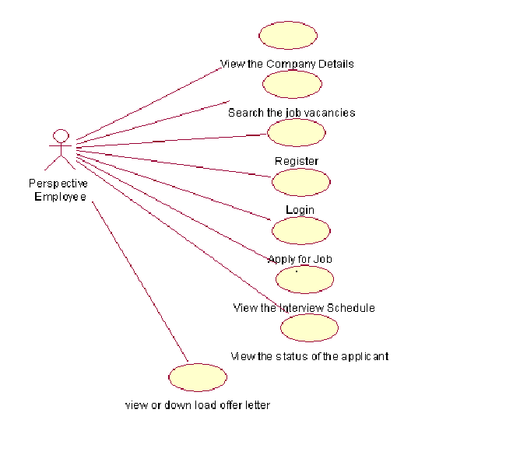
Administrator Module
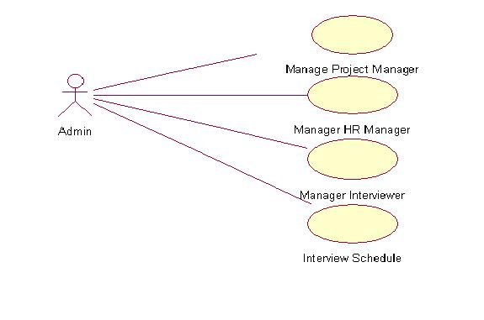

HR Manager

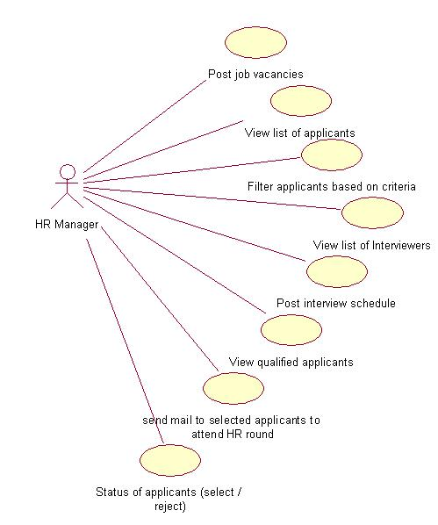

Interviewer

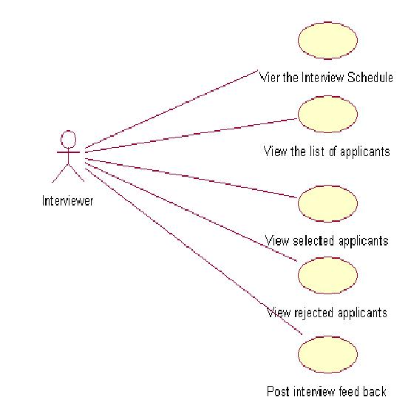

Look Up Table

S.No | Requirement ID | Requirement Name | Actors | Stable (Y/N) | Priority | Need | Verifiable  (y/n)
1 | EIS_PersEmp_UC_01 | View Details of Company | Perspective Employee | Y | High | Essential | Y
2 | EIS_PersEmp_UC_02 | Search Job Vacancies | Perspective Employee | Y | High | Essential | Y
3 | EIS_PersEmp_UC_03 | Register | Perspective Employee | Y | High | Essential | Y
4 | EIS_PersEmp_UC_04 | Login | Perspective Employee | Y | High | Essential | Y
5 | EIS_PersEmp_UC_05 | Apply Job | Perspective Employee | Y | High | Essential | Y
6 | EIS_PersEmp_UC_06 | View Interview Schedule | Perspective Employee | Y | High | Essential | Y
7 | EIS_PersEmp_UC_07 | View Status of Applicant | Perspective Employee | Y | High | Essential | Y
8 | EIS_PersEmp_UC_08 | View or download offer letter | Perspective Employee | Y | High | Essential | Y
9 | EIS_Admin_UC_01  (View) | Project Manager | Administrator | Y | High | Essential | Y
10 | EIS_Admin_UC_01  (Add) | Project Manager | Administrator | Y | High | Essential | Y
11 | EIS_Admin_UC_01  (Update) | Project Manager | Administrator | Y | High | Essential | Y
12 | EIS_Admin_UC_01  (Delete) | Project Manager | Administrator | Y | High | Essential | Y
13 | EIS_Admin_UC_02  (View) | HR Manager | Administrator | Y | High | Essential | Y
14 | EIS_Admin_UC_02  (Add) | HR Manager | Administrator | Y | High | Essential | Y
15 | EIS_Admin_UC_02  (Update) | HR Manager | Administrator | Y | High | Essential | Y
16 | EIS_Admin_UC_02  (Delete) | HR Manager | Administrator | Y | High | Essential | Y
17 | EIS_Admin_UC_03  (View) | Interviewer | Administrator | Y | High | Essential | Y
18 | EIS_Admin_UC_03  (Add) | Interviewer | Administrator | Y | High | Essential | Y
19 | EIS_Admin_UC_03  (Update) | Interviewer | Administrator | Y | High | Essential | Y
20 | EIS_Admin_UC_03  (Delete) | Interviewer | Administrator | Y | High | Essential | Y
21 | EIS_Admin_UC_04  (View) | Interview Schedule | Administrator | Y | High | Essential | Y
22 | EIS_Admin_UC_04  (Add) | Interview Schedule | Administrator | Y | High | Essential | Y
23 | EIS_Admin_UC_04  (Update) | Interview Schedule | Administrator | Y | High | Essential | Y
24 | EIS_Admin_UC_04  (Delete) | Interview Schedule | Administrator | Y | High | Essential | Y
25 | EIS_HR MANAGER_UC_01 | Post Job vancancancies | HR Manager | Y | High | Essential | Y
26 | EIS_HR MANAGER_UC_02 | View list of applicants | HR Manager | Y | High | Essential | Y
27 | EIS_HR MANAGER_UC_03 | Filter the applicants based on criteria | HR Manager | Y | High | Essential | Y
28 | EIS_HR MANAGER_UC_04 | View list of interviewers | HR Manager | Y | High | Essential | Y
29 | EIS_HR MANAGER_UC_05 | Post Interview schedule | HR Manager | Y | High | Essential | Y
30 | EIS_HR MANAGER_UC_06 | View Qualified Applicants | HR Manager | Y | High | Essential | Y
31 | EIS_HR MANAGER_UC_07 | Send a mail to selected applicants to attend HR round | HR Manager | Y | High | Essential | Y
32 | EIS_HR MANAGER_UC_08 | Status of applicants | HR Manager | Y | High | Essential | Y
33 | EIS_INTERVIEWER_UC_01 | View the interview Schedule | Interviewer | Y | High | Essential | Y
34 | EIS_INTERVIEWER_UC_02 | View the list of applicants | Interviewer | Y | High | Essential | Y
35 | EIS_INTERVIEWER_UC_03 | View the selected applicants | Interviewer | Y | High | Essential | Y
36 | EIS_INTERVIEWER_UC_04 | View the rejected applicants | Interviewer | Y | High | Essential | Y
37 | EIS_INTERVIEWER_UC_05 | Post interview Feed back | Interviewer | Y | High | Essential | Y

Module: Perspective Employee

Requirement ID | EIS_PersEmp_UC_01
Module Name | Perspective Employee Module
Use Case Name | View the company details
Use Case Description | Perspective employee will view the details of the company to apply for a job.
Primary Actor | Perspective Employee
Use case Diagram | 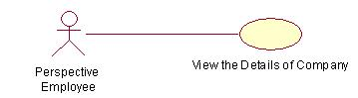
Precondition | 1.Organization notifies about the recruitments  2.Perspective employee view the details of the company
Post condition | Perspective employee enters into the login page
Basic Flow | - Perspective employee opens the company website.  - He views the company details.
Input | ---------Not Applicable----------
Output | ---------Not Applicable----------
Special instructions | Enter the valid organization web site

Requirement ID | EIS_PersEmp_UC_02
Module Name | Perspective Employee Module
Use Case Name | Check the details of vacancies
Use Case Description | perspective employee views the details of the vacancies in company
Primary Actor | Perspective Employee
Use case Diagram | 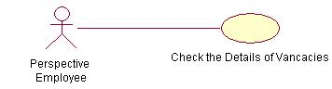
Precondition | 1.Enters into organization website  2.He view the details of company vacancies
Post condition | ---------Not Applicable----------
Basic Flow | - Perspective employee opens the company website.  - He views details of company and vacancies.  - View the details and description of jobs to apply.
Input | ---------Not Applicable----------
Output | ---------Not Applicable----------
Alternate Flows | ---------Not Applicable----------
Special instructions | ---------Not Applicable----------
Requirement ID |  | EIS_PersEmp_UC_03
Module Name |  | Perspective Employee Module
Use Case Name |  | Registration
Use Case Description |  | Here using the use case the perspective employee will register him/her self to the company then company provides a temporary login id and password to that perspective employee.
Primary Actor |  | Perspective Employee
Use case Diagram |  | 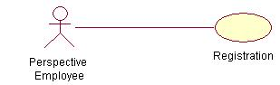
Precondition |  | He enters into the website.
Post condition |  | Submit details of perspective employee to organization.
Basic Flow |  | - Perspective employee opens the company website  - It displays login for registration.  - Applicant should enter the details in the registration form
Input |  | - Perspective employee details  - Enter name  - Select sex  1.3Select date of birth  - Enter address  - Enter contact number  - Enter mail id  - Qualification details  - Select course  - Select year of passed out  - Experience details  - Enter name of the organization  - Enter employee designation  - Select joined and relieve date  - Enter achievements  - skills of the perspective employee  - Select Technical skills  - Select Languages known
Output |  | Displays username  Displays password
Alternate Flows |  | ---------Not Applicable----------

Requirement ID | EIS_PersEmp_UC_04
Module Name | Perspective Employee Module
Use Case Name | login ID/ select job
Use Case Description | Here Perspective Employee will login into the company to apply for a job.
Primary Actor | Perspective Employee
Use case Diagram | 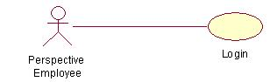
Precondition | Person should be registered.
Post condition | View the job vacancies webpage.
Basic Flow | - Enter the user id  2. Enter the password
Input | 1.Enter login id and  2.Enter password
Output | ---------Not Applicable----------
Alternate Flows | Enter valid user id  Enter valid Password.
Special instructions | ------------Not Applicable-------------------
 | Requirement ID |  | EIS_PersEmp_UC_05
 | Module Name |  | Perspective Employee Module
 | Use Case Name |  | Post resume to company
 | Use Case Description |  | This use case represents that the perspective employee will post his resume to the company
 | Primary Actor |  | Perspective Employee
 | Use case Diagram |  | 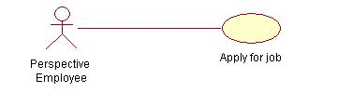
 | Precondition |  | The Perspective employee Login to the organization.
 | Post condition |  | Receives acknowledgement message.
 | Basic Flow |  | - Login to the job vacancies webpage.  - Choose the job  2.1 Apply to the selected job.
 | Input |  | - List of jobs  - Apply for job
 | Output |  | Receives acknowledgement message.
 | Alternate Flows |  | --------------Not Applicable-----------------------
 | Special instructions |  | --------------Not Applicable-----------------------
Requirement ID |  | EIS_PersEmp_UC_06
Module Name |  | Perspective Employee Module
Use Case Name |  | View the details of the interview.
Use Case Description |  | The use case shows the perspective employee can view the details of the interviews schedules that are mailed by the organization.
Primary Actor |  | Perspective Employee
Use case Diagram |  | 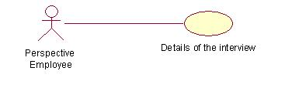
Precondition |  | Apply to the job
Post condition |  | ---------Not Applicable----------
Basic Flow |  | - Apply for the job  - Receive select/reject acknowledgment  - If receive select acknowledge  - Receives the interview schedule.  - Display date and time.  - Modules of interview  - Attend the interview.
Input |  | 1. Date and time of the interview.  2.Modules of interview
Output |  | ---------Not Applicable----------
Alternate Flows |  | ---------Not Applicable----------

Requirement ID | EIS_PersEmp_UC_07
Module Name | Perspective Employee Module
Use Case Name | View the status of applicant.
Use Case Description | This use case describes about the status of interview completed applicant that weather he/she is selected or rejected.
Primary Actor | Perspective Employee
Use case Diagram | 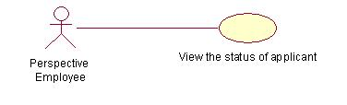
Precondition | Perspective employee should attend the interview process
Post condition | ---------Not Applicable----------
Basic Flow | - Applicant attend the interview  - applicant complete the all the modules of interview  - Interviewer finalize the results  - select  - reject
Input | ----------------Not Applicable------------
Output | Acknowledgement about selected applicants sends to the company.
Alternate Flows | Perspective employee must qualify the interview rounds conducted by the organization.
Special instructions | Perspective employee should follow the criteria specified by the enterprise.

Requirement ID | EIS_PersEmp_UC_08
Module Name | Perspective Employee Module
Use Case Name | View the offer letter
Use Case Description | Use case maintains perspective employee offer letter.
Primary Actor | Perspective Employee
Use case Diagram | 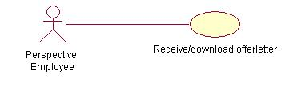
Precondition | The Perspective Employee should be selected in interview
Post condition | --------Not applicable----------
Basic Flow | - Perspective employee login to website  - Select the job and forward resume  - Receives selected acknowledgement  - Receives interview schedule  - Attend the interview  - Status of applicant  - Receive or download offer letter with job id.
Input | - Attend the interview
Output | ---------------Not Applicable-------------------
Alternate Flows | --------------- Not Applicable----------
Special instructions | Check the status of applicant

Module: Admin

Use Case 1: Project Manger Manages

Requirement ID | EIS_Admin_UC_01(View)
Module Name | Admin Module
Use Case Name | Manages the Project Manager
Use Case Description | This Use case contains list and details of the project manager.
Primary Actor | Admin
Use case Diagram | 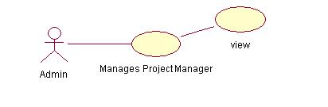
Precondition | Admin should login
Post condition | ---------Not Applicable----------
Basic Flow | - Admin should login  - View the list of project manager  2.1 View the details of the project manager.
Input | ----------Not Applicable------------------
Output | ----------Not Applicable------------------
Alternate Flows | ---------Not Applicable----------
Special instructions | ---------Not Applicable----------

Requirement ID | EIS_Admin_UC_01(Add)
Module Name | Admin Module
Use Case Name | Manages the Project Manager
Use Case Description | This Use case maintains project manager operations such as recruiting of new project managers.
Primary Actor | Admin
Use case Diagram | 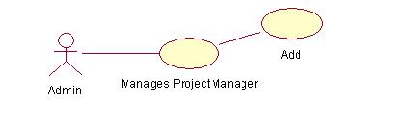
Precondition | Admin should login
Post condition | ----------Not Applicable------------------
Basic Flow | - Admin should login  - Enter the details of the project manager  2.1enter the first name  2.2enter the last name  2.3select the D.O.B  2.4enter the contact name  2.5 enter the mail id  2.6 select the location of the branch  2.7 select the employee id  2.8 select the department id  3.Click on submit  4.Click on confirmation
Input | Selected project manager
Output | ----------Not Applicable------------------
Alternate Flows | - Enter the valid employee id
Special instructions | ----------Not Applicable------------------

Requirement ID | EIS_Admin_UC_02(Update)
Module Name | Admin Module
Use Case Name | Manages the Project Manager
Use Case Description | This Use case maintains project manager operations such as updating new from existed and any internal changes of project managers.
Primary Actor | Admin
Use case Diagram | 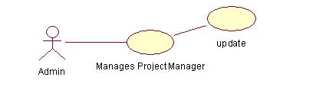
Precondition | Admin should login
Post condition | ----------Not Applicable------------------
Basic Flow | - Admin should login  - Update the details of the project manager  2.1update the contact name  2.2update the mail id  2.3update the location of the branch  2.4update the employee id  3.Click on submit  4. Click on confirmation.
Input | Selected project manager
Output | ----------Not Applicable------------------
Alternate Flows | Enter valid employee id
Special instructions | ----------Not Applicable------------------

Requirement ID | EIS_Admin_UC_01(delete)
Module Name | Admin Module
Use Case Name | Manages the Project Manager
Use Case Description | This Use case maintains operations such as deleting of project manager.
Primary Actor | Admin
Use case Diagram | 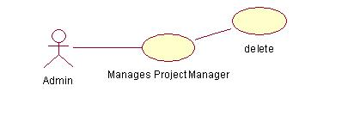
Precondition | Admin should login
Post condition | Particular project manager details will be deleted
Basic Flow | - Admin should login  - View the project manager details  - Select the project manager  Click on delete
Input | Resignation letter
Output | -------------------Not Applicable-------------------
Alternate Flows | Resignation accept/reject
Special instructions | ----------Not Applicable------------------.

Use Case 2: HR Manger Manages

Requirement ID | EIS_Admin_UC_02(View)
Module Name | Admin Module
Use Case Name | Manages the HR Manager
Use Case Description | This Use case contains list and details of the HR manager.
Primary Actor | Admin
Use case Diagram | 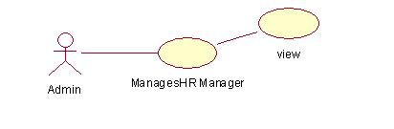
Precondition | Admin should login
Post condition | ----------Not Applicable------------------
Basic Flow | - Admin should login  - View the list of HR manager  2.1 View the details of the HR manager.
Input | ----------Not Applicable------------------
Output | ----------Not Applicable------------------
Alternate Flows | ----------Not Applicable------------------
Special instructions | -----------Not Applicable------------

Requirement ID | EIS_Admin_UC_02(Add)
Module Name | Admin Module
Use Case Name | Manages the HR Manager
Use Case Description | This Use case maintains HR manager operations such as recruiting of new project managers.
Primary Actor | Admin
Use case Diagram | 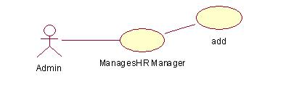
Precondition | Admin should login
Post condition | ----------Not Applicable------------------
Basic Flow | - Admin should login  - Enter the details of the Hr manager  2.1enter the first name  2.2enter the last name  2.3select the D.O.B  2.4enter the contact name  2.5enter the mail id  2.6select the location of the branch  2.7select the employee id  2.8select the department id  3.Click on submit  4.Click on confirmation
Input | Selected project manager
Output | ----------Not Applicable------------------
Alternate Flows | - Enter valid employee id
Special instructions | ----------Not Applicable------------------

Requirement ID | EIS_Admin_UC_02(Update)
Module Name | Admin Module
Use Case Name | Manages the HR Manager
Use Case Description | This Use case maintains HR manager operations such as updating new from existed and any internal changes of HR managers.
Primary Actor | Admin
Use case Diagram | 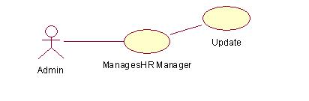
Precondition | Admin should login
Post condition | ----------Not Applicable------------------
Basic Flow | - Admin should login  - Update the details of the project manager  2.1update the contact name  2.2update the mail id  2.3update the location of the branch  2.4update the employee id  3.Click on submit  4. Click on confirmation.
Input | Selected project manager
Output | ----------Not Applicable------------------
Alternate Flows | Enter valid employee id
Special instructions | ----------Not Applicable------------------

Requirement ID | EIS_Admin_UC_02(delete)
Module Name | Admin Module
Use Case Name | Manages the HR Manager
Use Case Description | This Use case maintains operations such as deleting of  HR manager.
Primary Actor | Admin
Use case Diagram | 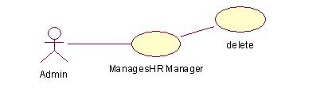
Precondition | Admin should login
Post condition | Deleted manager details
Basic Flow | - Admin should login  - View the details of HR manager  - Delete the HR manager
Input | Resignation letter
Output | ----------Not Applicable------------------
Alternate Flows | Resignation accept/reject
Special instructions | . ----------Not Applicable------------------

Use Case 3: Interviewer Manger Manages
Requirement ID | EIS_Admin_UC_03(View)
Module Name | Admin Module
Use Case Name | Manages the Interviewer
Use Case Description | This Use case contains list and details of the Interviewer.
Primary Actor | Admin
Use case Diagram | 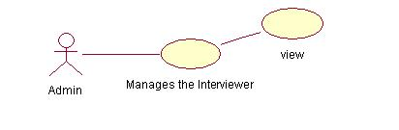
Precondition | Admin should login
Post condition | -------------Not Applicable-----------
Basic Flow | - Admin should login  - View the list of interviewer  2.1 View the details of the interviewer
Input | -------------Not Applicable-----------
Output | -------------Not Applicable-----------
Alternate Flows | -------------Not Applicable-----------
Special instructions | -------------Not Applicable-----------
Requirement ID | EIS_Admin_UC_02(Add)
Module Name | Admin Module
Use Case Name | Manages the Interviewer
Use Case Description | This Use case maintains Interviewer operations such as recruiting of new Interviewers.
Primary Actor | Admin
Use case Diagram
Precondition | Admin should login
Post condition | ----------Not Applicable------------------
Basic Flow | - Admin should login  - Enter the details of the interviewer  2.1enter the first name  2.2enter the last name  2.3select the D.O.B  2.4enter the contact name  2.5enter the mail id  2.6select the location of the branch  2.7select the employee id  2.8select the department id  3.Click on submit  4.Click on confirmation
Input | Selected project manager
Output | ----------Not Applicable------------------
Alternate Flows | - Enter valid employee id
Special instructions | ----------Not Applicable------------------

Requirement ID | EIS_Admin_UC_02(Update)
Module Name | Admin Module
Use Case Name | Manages the Interviewer
Use Case Description | This Use case maintains Interviewer operations such as updating new from existed and any internal changes of Interviewer.
Primary Actor | Admin
Use case Diagram | 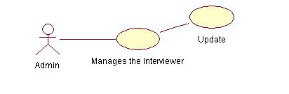
Precondition | Admin should login
Post condition | ----------Not Applicable------------------
Basic Flow | - Admin should login  - Update the details of the interviewer  2.1update the contact name  2.2update the mail id  2.3update the location of the branch  2.4update the employee id  3.Click on submit  4. Click on confirmation.
Input | Selected project manager
Output | ----------Not Applicable------------------
Alternate Flows | Enter valid employee id
Special instructions | ----------Not Applicable------------------

Requirement ID | EIS_Admin_UC_02(delete)
Module Name | Admin Module
Use Case Name | Manages the Interviewer
Use Case Description | This Use case maintains operations such as deleting of Interviewer.
Primary Actor | Admin
Use case Diagram | 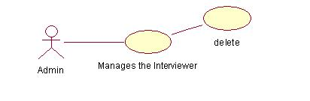
Precondition | Admin should login
Post condition | Deleted interviewer details
Basic Flow | - Admin should login  - View the details of interviewer  - Delete the interviewer
Input | Resignation letter
Output | ----------Not Applicable------------------
Alternate Flows | Resignation accept/reject
Special instructions | . ----------Not Applicable------------------

Use Case 4: Interview Schedule

Requirement ID | EIS_Admin_UC_04(View)
Module Name | Admin Module
Use Case Name | Manages the Interview Schedule
Use Case Description | This Use case contains list and details of the Interview schedule conducting by the organization.
Primary Actor | Admin
Use case Diagram | 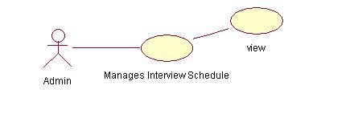
Precondition | Create schedule of the interview
Post condition | ------------------Not Applicable------------------
Basic Flow | - Login in to the administrator (HR Manager).  1.1 view the interview schedule
Input | Login to the administrator
Output | ------------------Not Applicable------------------
Alternate Flows | ------------------Not Applicable------------------
Special instructions | ------------------Not Applicable------------------
Requirement ID | EIS_Admin_UC_04(Add)
Module Name | Admin Module
Use Case Name | Manages the Interview Schedule
Use Case Description | This Use case maintains Interviewer operations such as adding of new Interview Schedule.
Primary Actor | Admin
Use case Diagram | 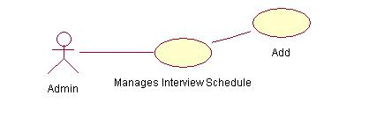
Precondition | Create the interview schedule
Post condition | -----------------Not Applicable------------
Basic Flow | - Admin should login  - Create the Interview Schedule.  - Enter the date  - Enter the time  - Enter the location of branch  - 2 . Add the Interview Schedule.
Input | -----------------Not Applicable------------
Output | -----------------Not Applicable------------
Alternate Flows | -----------------Not Applicable------------
Special instructions | -----------------Not Applicable------------

Requirement ID | EIS_Admin_UC_04(Change)
Module Name | Admin Module
Use Case Name | Manages the Interview Schedule
Use Case Description | This Use case maintains Interview Schedule operations such as changing in to new from existed and any internal changes of Interview Schedule.
Primary Actor | Admin
Use case Diagram | 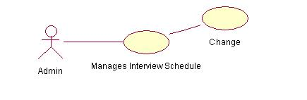
Precondition | View the Interview schedule
Post condition | -----------------Not Applicable------------
Basic Flow | - Selects the Interview Schedule.  - Change the interview schedule.  2.1 Update the Interview Schedule.
Input | Selects the Interview Schedule.
Output | -----------------Not Applicable------------
Requirement ID | EIS_Admin_UC_04(Remove)
Module Name | Admin Module
Use Case Name | Manages the Interview Schedule
Use Case Description | This Use case maintains operations such as removing of Interview Schedule.
Primary Actor | Admin
Use case Diagram | 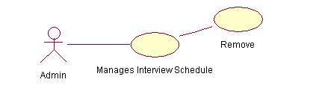
Precondition | View the Interview schedule
Post condition | -----------------Not Applicable------------
Basic Flow | - View the interview schedule  - Remove the unfeasible schedule.
Input | -----------------Not Applicable------------
Output | -----------------Not Applicable------------
Alternate Flows | -----------------Not Applicable------------
Special instructions | -----------------Not Applicable------------

Module: HR Module
Requirement ID | EIS_HR MANAGER_UC_01
Module Name | HR Module
Use Case Name | Post the job vacancies
Use Case Description | This use case describes the Hr Manager posts the job vacancies/openings of the company.
Primary Actor | Hr Manager
Use case Diagram | Hr Manager  Post the job  Vacancies
Precondition | The project manager should inform about the vacancies to the Hr Manager.
Post condition | The Hr Manager can view the list of applicants.
Basic Flow | - The project manager should inform about the vacancies to the Hr Manager.  1.1 The Hr Manager View the details of jobs to recruit applicants. 1.2. HR manager post the jobs vacancies.
Input | Details of the jobs
Output | ------------------Not Applicable-------------------------
Alternate Flows | ------------------Not Applicable-------------------------

Requirement ID | EIS_HR MANAGER_UC_02
Module Name | HR Module
Use Case Name | View the list of applicants
Use Case Description | This use case is used to View the list of applicants by the HR representative.
Primary Actor | Hr Manager
Use case Diagram | Hr Manager  View the list of  applicants
Precondition | - HR Manager should login .
Post condition | The HR Manager will get the filtered applicants.
Basic Flow | - HR manager should login  - View the list of applicants
Input | ----------------Not Applicable----------------------------
Output | ----------------Not Applicable----------------------------
Alternate Flows | ----------------Not Applicable----------------------------
Special instructions | ----------------Not Applicable----------------------------

Requirement ID | EIS_HR MANAGER_UC_03
Module Name | HR Module
Use Case Name | Filter the applicants based on criteria.
Use Case Description | Here using this use case the Hr Manager can choose the applicants based on criteria of the organization.
Primary Actor | Hr Manager
Use case Diagram | Hr Manager  Filter the applicants
Precondition | The Hr Manager views the list of applicants.
Post condition | Selected applicants list
Basic Flow | - View the list of applicants  - Filter applicants based on  - percentage  - experience  - skill set
Input | List of applicants
Output | Selected applicants
Alternate Flows | - Selected applicants should get acknowledgement  - Rejected applicants should get acknowledgement
Special instructions | Filtration based on the organizational criteria.

Requirement ID | EIS_HR MANAGER_UC_04
Module Name | HR Module
Use Case Name | View the list of interviewers.
Use Case Description | Here using this use case the Hr Manager can View the list of interviewers.
Primary Actor | Hr Manager
Use case Diagram | Hr Manager  View the list of  interviewers
Precondition | Login to admin
Post condition | --------------Not Applicable------------------------
Basic Flow | - HR manager should login  - HR Manager view the list of interviewers
Input | --------------Not Applicable------------------------
Output | --------------Not Applicable------------------------
Alternate Flows | --------------Not Applicable------------------------
Special instructions | --------------Not Applicable------------------------

Requirement ID | EIS_HR MANAGER_UC_05
Module Name | HR Module
Use Case Name | Post the interview schedule.
Use Case Description | Here using this use case the Hr Manager can Post the interview schedule to the interviewers and applicants.
Primary Actor | Hr Manager
Use case Diagram | Hr Manager  Post the interview  schedule
Precondition | Prepare interview schedule
Post condition | The interviewers conduct the interview and submit the feedback.
Basic Flow | - Hr manager post interview schedule to Interviewer.  - Hr manager post interview schedule to applicant
Input | - Interview schedule  - date and time  - modules of interview
Output | --------------Not Applicable------------------------
Alternate Flows | --------------Not Applicable------------------------
Special instructions | Interview schedule should be updated

Requirement ID | EIS_HR MANAGER_UC_06
Module Name | HR Module
Use Case Name | View qualified applicants.
Use Case Description | Here using this use case the Hr Manager can View the qualified applicants of Technical round.
Primary Actor | Hr Manager
Use case Diagram | Hr Manager  View qualified  applicants
Precondition | Applicants selected in filter process
Post condition | --------------Not Applicable------------------------
Basic Flow | - HR manager should login  - Views the qualified applicants in technical round
Input | Qualified applicants
Output | --------------Not Applicable------------------------
Alternate Flows | --------------Not Applicable------------------------
Special instructions | --------------Not Applicable------------------------

Requirement ID | EIS_HR MANAGER_UC_07
Module Name | HR Module
Use Case Name | Send mail to the selected applicants to attend the Hr round.
Use Case Description | Here using this use case the Hr Manager can Send mail to the selected applicants to attend the Hr round.
Primary Actor | Hr Manager
Use case Diagram | Hr Manager  Send mail to the Selected  applicants to attend the interview
Precondition | Should be qualified in technical round.
Post condition | Receive the offer letter / receive the rejected mail.
Basic Flow | - Login to admin  - Post mail to the selected candidates.  - Post mail to the rejected candidates.
Input | Selected candidates in technical round
Output | Applicant receives the acknowledgements.
Alternate Flows | Rejected candidates receive the acknowledgment with reason they are rejected.
Special instructions | -----------------Not Applicable------------------------

Module: Interviewer

Requirement ID | EIS_INTERVIEWER_UC_01
Module Name | Interviewer Module
Use Case Name | View the interview schedule
Use Case Description | Here using this use case the interviewer can view the details of the interview schedule.
Primary Actor | Interviewer
Use case Diagram | Interviewer  View the  Interview schedule
Precondition | Receive Interview module from Hr manager.
Post condition | ---------------------Not Applicable--------------------------------
Basic Flow | - Interviewer View the details of the interview schedules  - View the date and timings.
Input | Interview schedule
Output | ---------------------Not Applicable--------------------------------
Alternate Flows | ---------------------Not Applicable--------------------------------
Special instructions | Date and time should divided among list of applicants

Requirement ID | EIS_INTERVIEWER_UC_02
Module Name | Interviewer Module
Use Case Name | View the list of applicants
Use Case Description | Here using this use case the interviewer can view the details of the number of applicants.
Primary Actor | Interviewer
Use case Diagram | Interviewer  View the  list of sapplicants
Precondition | HR manager informs the interview schedule
Post condition | ---------------------Not Applicable--------------------------------
Basic Flow | - Receives the interview schedule  - Login to admin  - View the list of applicants
Input | List of applicants
Output | ---------------------Not Applicable--------------------------------
Alternate Flows | List of applicants with selected job id
Special instructions | Applicants should be entered valid job id.

Requirement ID | EIS_INTERVIEWER_UC_03
Module Name | Interviewer Module
Use Case Name | View the selected applicants.
Use Case Description | Here using this use case the interviewer can view the details of the  Selected applicants.
Primary Actor | Interviewer
Use case  Diagram | View the  Selected applicants  Interviewer
Precondition | Attend the interview
Post condition | ---------------------Not Applicable--------------------------------
Basic Flow | - The interviewer should conduct the interview to the applicants.  - The interviewer should give rating to applicants  Depending on their performance.  - The interviewer should submit the feedback.  - View the list of the selected applicants.
Input | Selected candidates
Output | ---------------------Not Applicable--------------------------------
Alternate Flows | Rejected candidate should receive their reject information along with reasons of rejecting.
Special instructions | The process should be done in an appropriate manner to select the  right applicants for the job.

Requirement ID | EIS_INTERVIEWER_UC_04
Module Name | Interviewer Module
Use Case Name | View the rejected applicants.
Use Case Description | Here using this use case the interviewer can view the details of the rejected applicants to send the mail to them about their rejection.
Primary Actor | Interviewer
Use case Diagram | Interviewer  View the  Rejected applicants
Precondition | - Applicants attend the interview process
Post condition | ---------------------Not Applicable--------------------------------
Basic Flow | - Interviewer login to administrator  - View the rejected applicants
Input | ---------------------Not Applicable--------------------------------
Output | ---------------------Not Applicable--------------------------------
Alternate Flows | ---------------------Not Applicable--------------------------------
Special instructions | ---------------------Not Applicable--------------------------------

Requirement ID | EIS_INTERVIEWER_UC_05
Module Name | Interviewer Module
Use Case Name | Post interview feedback
Use Case Description | Here using this use case the interviewer can post the details of the feedback to the applicants.
Primary Actor | Interviewer
Use case Diagram | Interviewer  Post interview feed  Back to HR
Precondition | Conduct technical round interview for the applicants.
Post condition | ---------------------Not Applicable-------------------------------
Basic Flow | - Login to the administrator  Post feed back to HR manager
Input | Selected applicants and  Rejected applicants
Output | ---------------------Not Applicable-------------------------------
Activity Diagrams

Actor : Perspective Employee
Diagram : View Company and Job Details

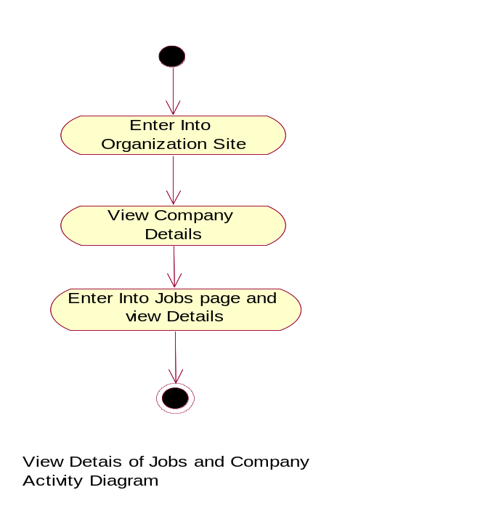

Actor : Perspective Employee
Diagram : View Interview Schedule
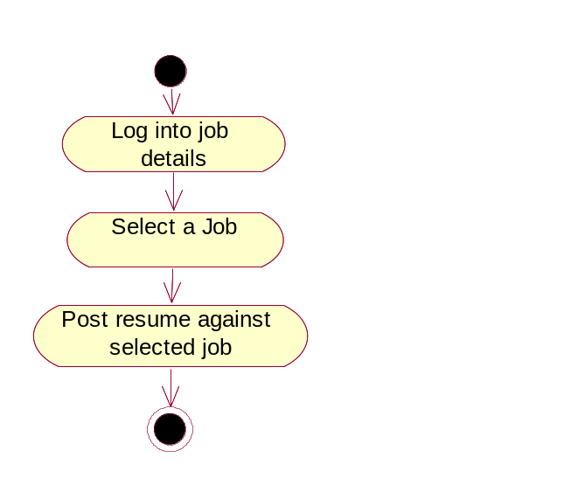

Actor : Perspective Employee
Diagram : Registration
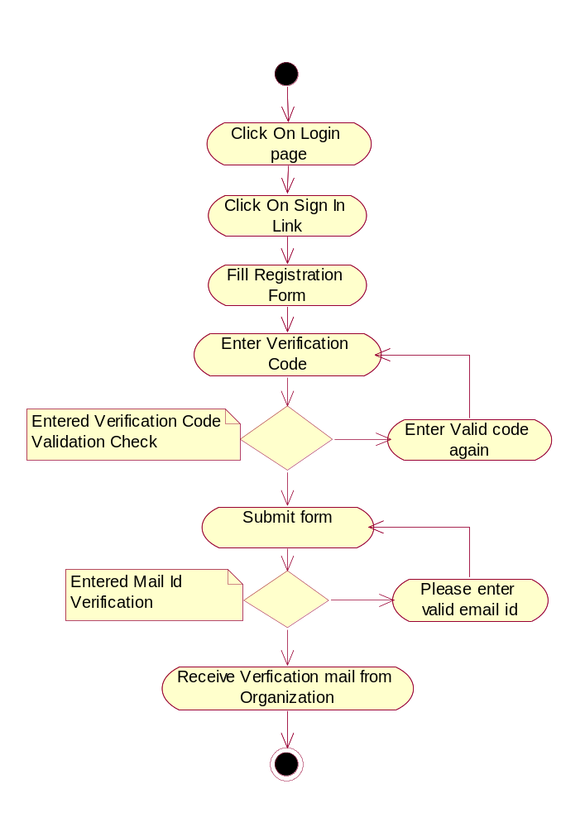

Actor : Perspective Employee
Diagram : login
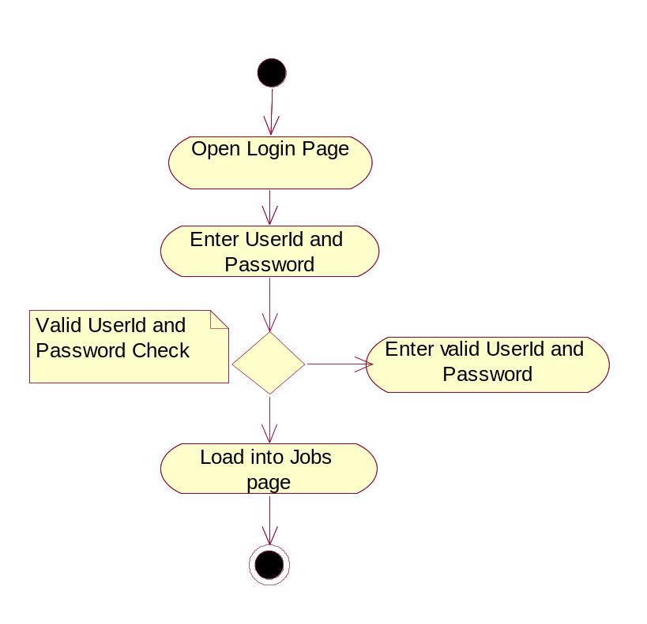

Actor : Perspective Employee
Diagram : View Interview Schedule

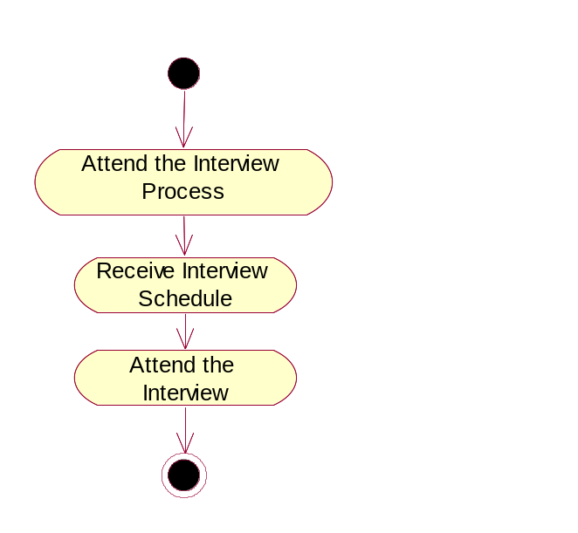

Actor : Perspective Employee
Diagram : Status of Applicant
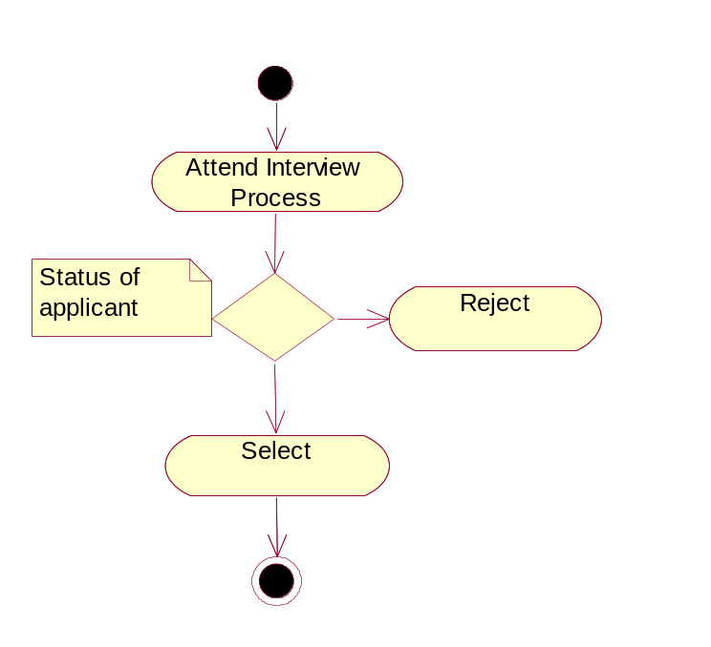

Actor : Admin
Diagram : Managing Project Manager
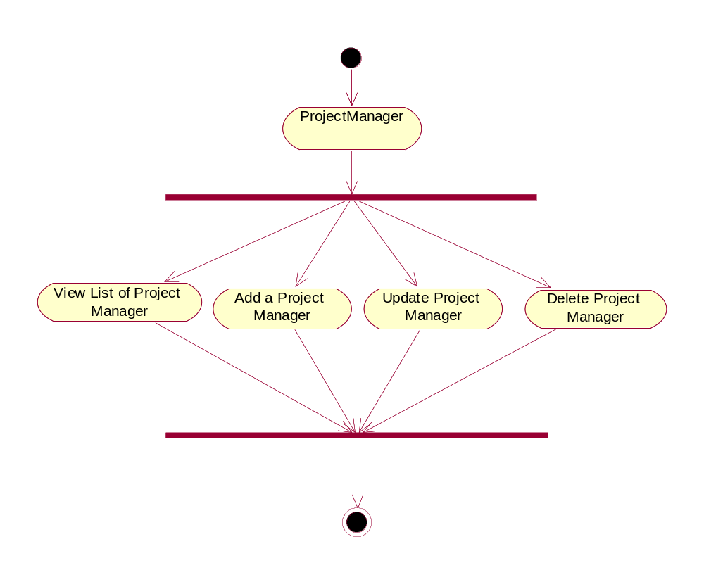
Actor : Admin
Diagram : Managing HR Manager
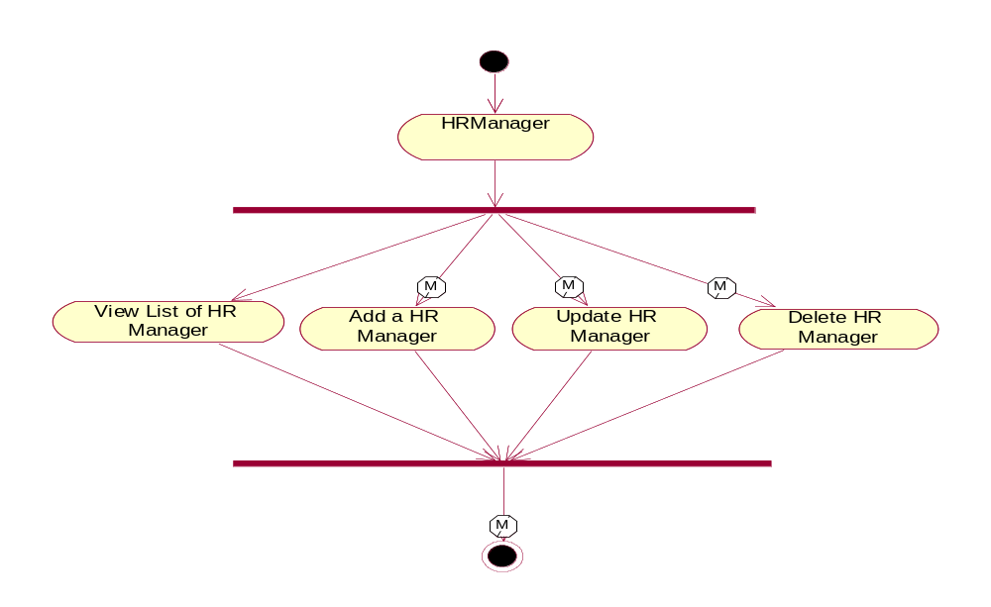
Actor : Admin
Diagram : Manages Interviewer
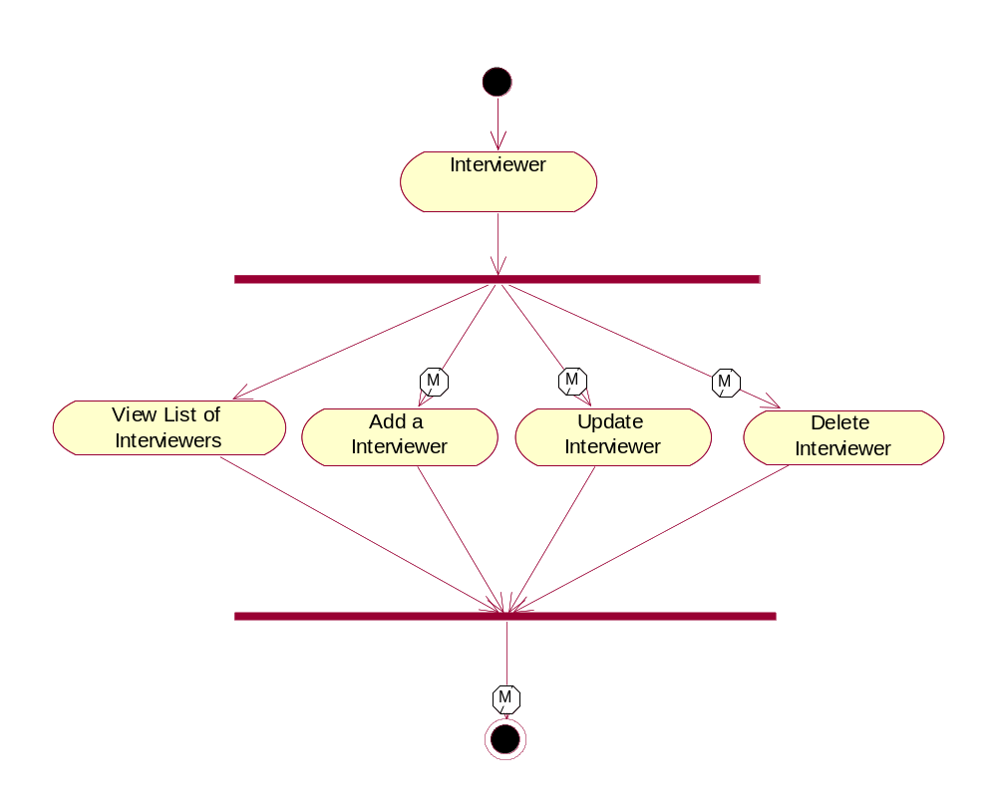

Actor : Admin
Diagram : Manages Interview Schedule
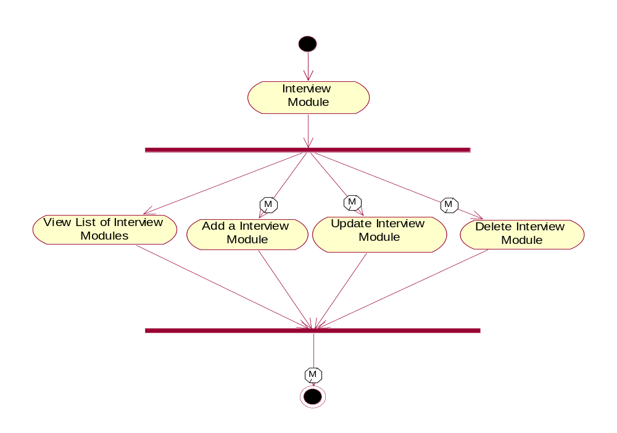

Actor : HR Manager
Diagram : View list of Applicants and Interviewer
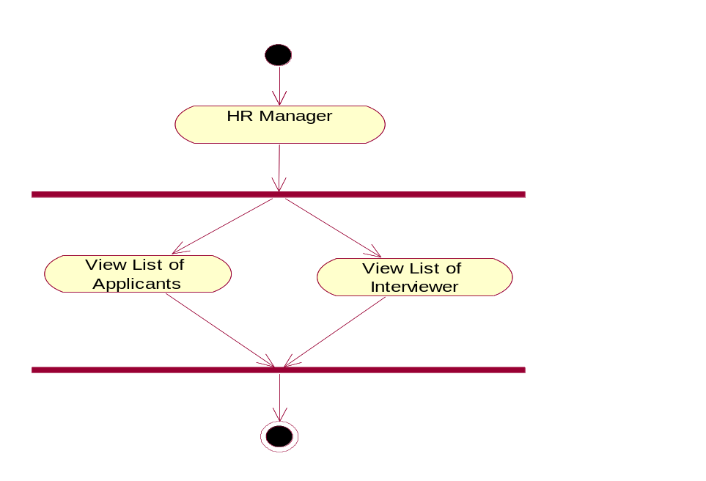

Actor : HR Manager
Diagram : View list of Applicants and Interviewer
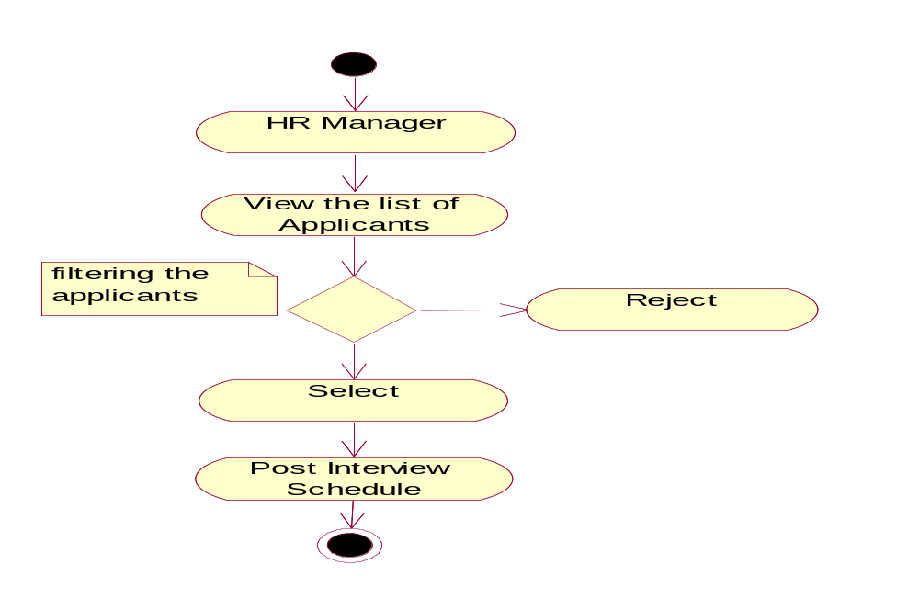

Actor : HR Manager
Diagram : Post Interview schedules to applicant

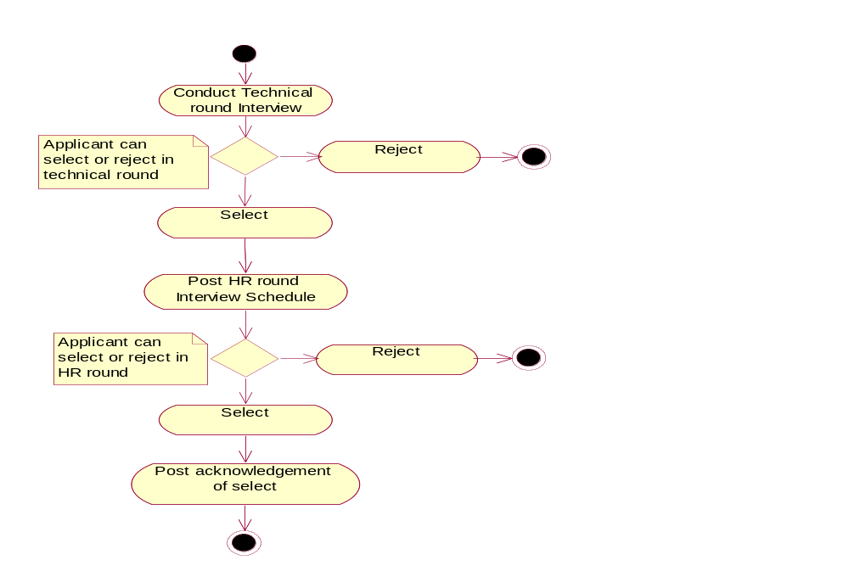

Actor : HR Manager
Diagram : Post Interview schedules to applicant
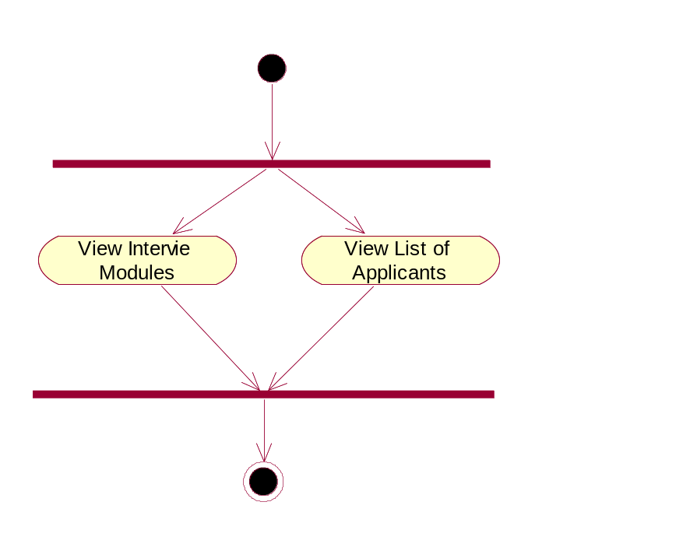

Actor : HR Manager
Diagram : Status of applicant and feed back to HR Manager
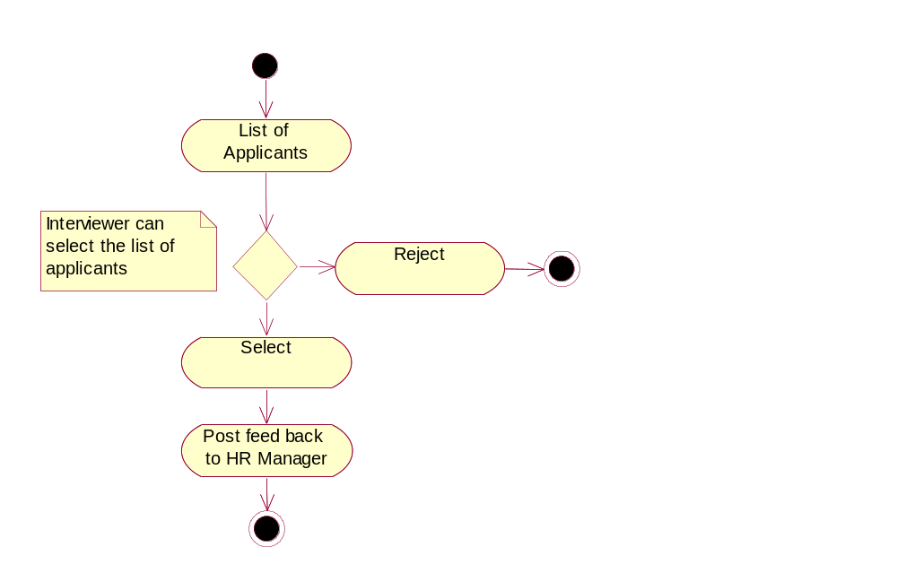

System Design

Sequence & Collaboration Diagrams

Use case: Perspective Employee

- View Company Details
- View Job Details

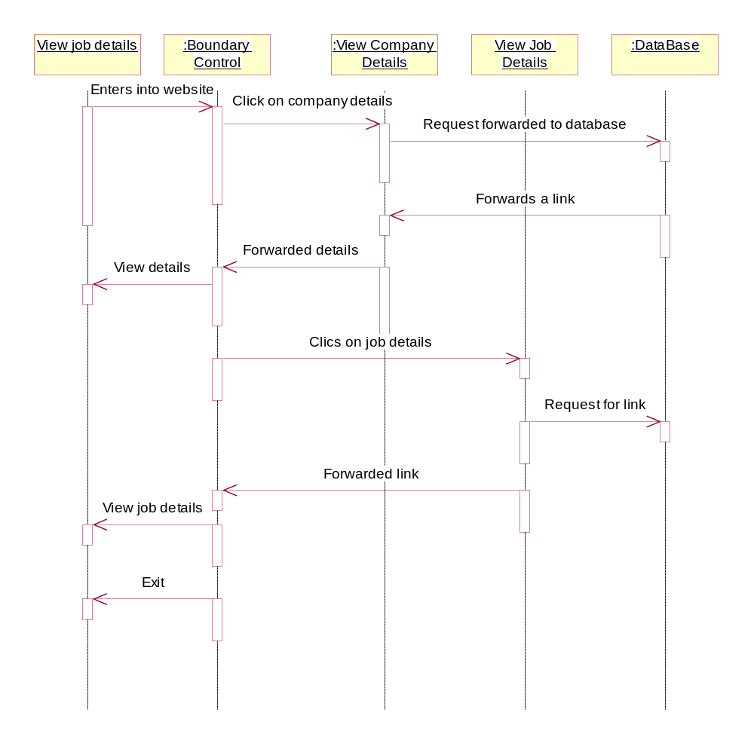

Collaboration Diagram:

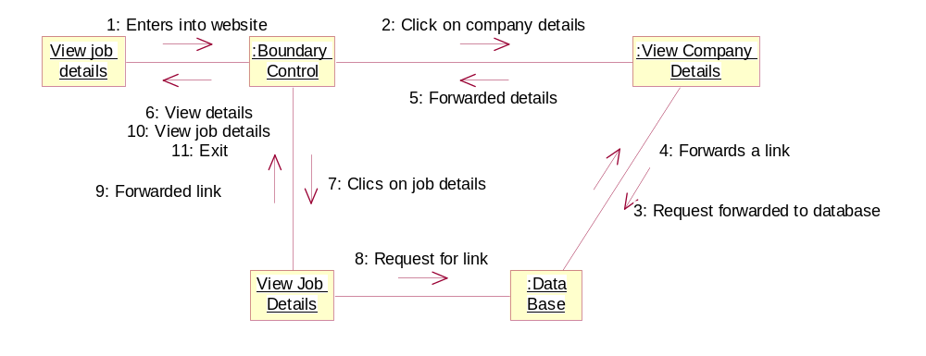

System Features Id | SF_E-Induction_PE_01
Requirement ID | EIS_PersEmp_UC_01
Actor | Perspective Employee
Business Logic | 1.Enter into website  2.View details  2.1 Clicks on campus details  2.2 Click on job details
Client side validation | Enter a valid website and clicks on the link
Server side validation | Required link page should provide.

Registration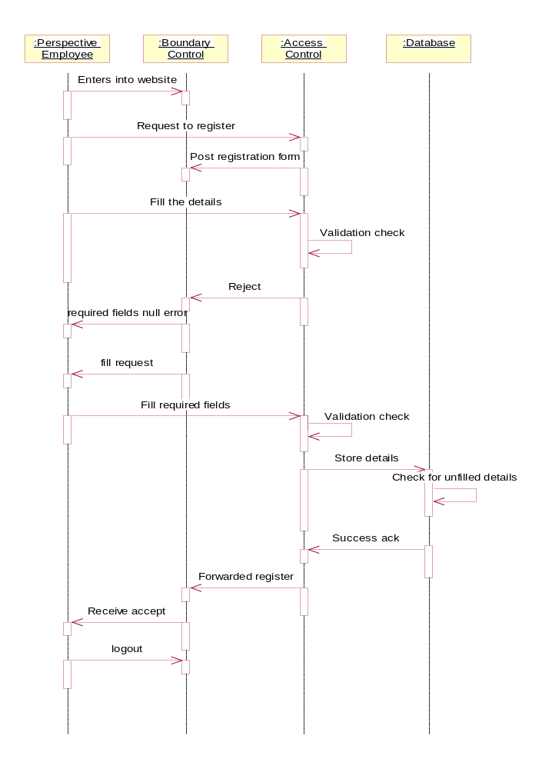

Collaboration Diagram

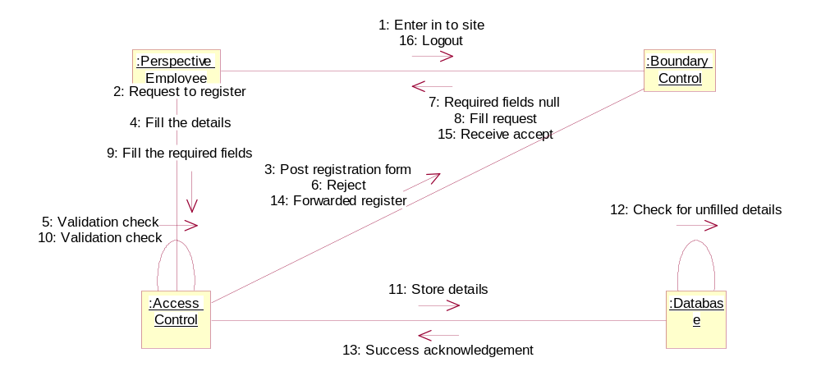

System Features Id | SF_E-Induction_PE_02
Requirement ID | EIS_PersEmp_UC_03
Actor | Perspective Employee
Business Logic | 1.Click on signup link  2.Fills the required fields  2.1 Register with i2labs  2.1.1 userid  2.1.2 Password  2.1.3 Confirm Password  2.1.4 Proceed to next step(Clicks on next button)  2.2 Personal details  2.2.1 Enter first name  2.2.2 Enter last name  2.2.3 Select title  2.2.4 select gender  2.2.5 Enter address  2.2.6 Select city  2.2.7 Select state  2.2.8 Select country  2.2.9 Enter contact details  2.3 Education details  2.3.1 Select highest qualification  2.3.2 Year of passed  2.3.3 Select second highest qualification  2.3.4 Year of passed  2.3.5 Enter diploma courses  2.3.6 Year of completed  2.4 Skill Set  2.4.1 Select languages(programming)  2.4.2 Select technical skills  2.4.3 Select operating systems  2.4.4Select speaking languages  2.4.5 Enter any others  2.5 Other Details  2.5.1 Enter passport no.  2.5.2 Date of passport issue  2.5.3 Enter pan card no.  2.5.4 Date of pan card card issue  2.6Upload Resume
Client side validation | 1. Enter required fields validation  2. Required fields fill acknowledgement
Server side validation | 1.Check for availability of userid and password  2. Store the details to database

Sequence Diagram
Login
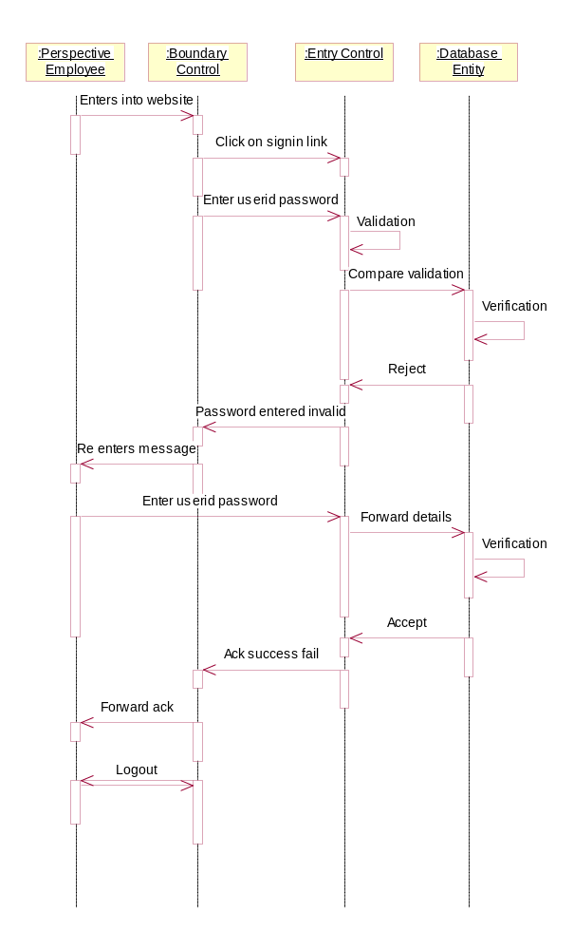

Collaboration Diagram

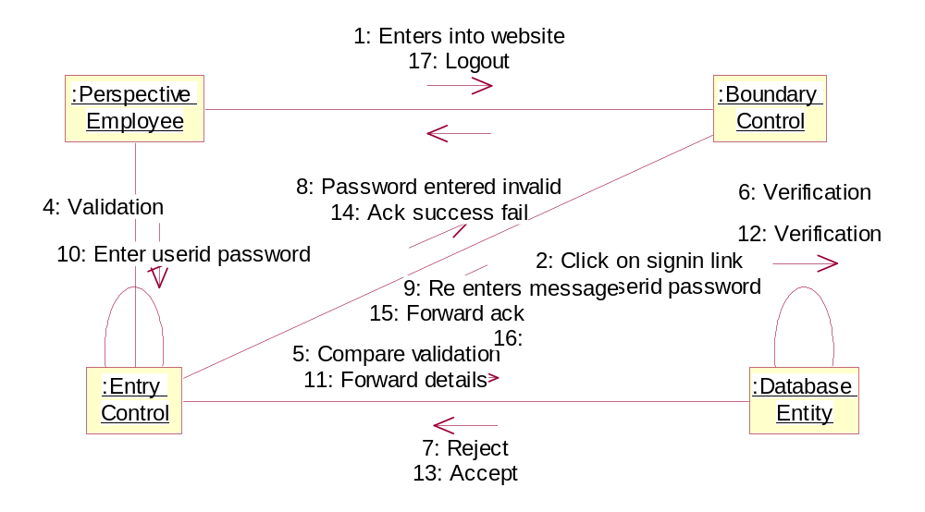

System Features Id | SF_E-Induction_PE_03
Requirement ID | EIS_PersEmp_UC_04
Actor | Perspective Employee
Business Logic | 1. Click on login page  2. Enter required fields  2.1 Enter userid  2.2Enter password  3. Click on signin link
Client side validation | 1. Verify the fields userid  2. Enter password
Server side validation | 1. Check userid existed  2. check password existed

Sequence Diagram
- Apply for job
- Receive interview schedule

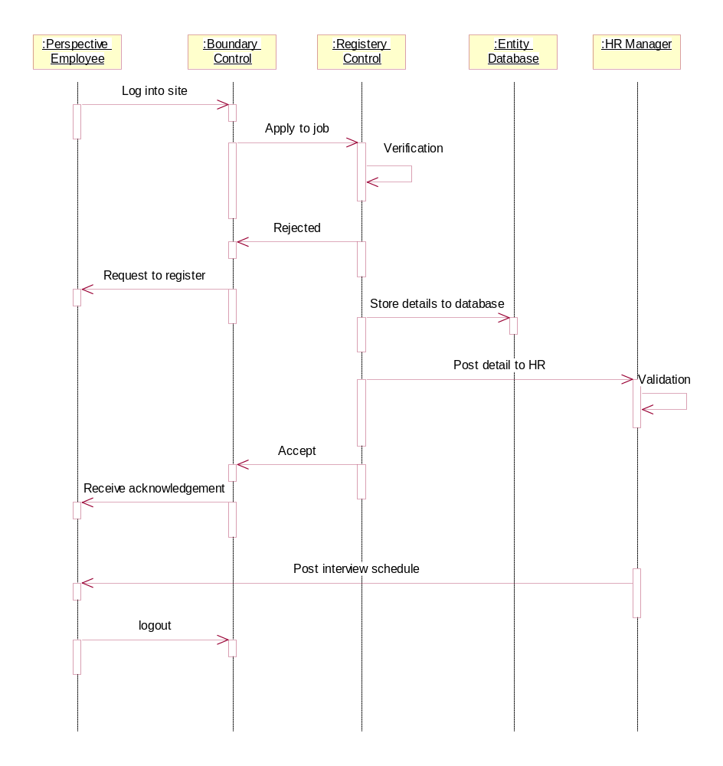

Collaboration Diagram
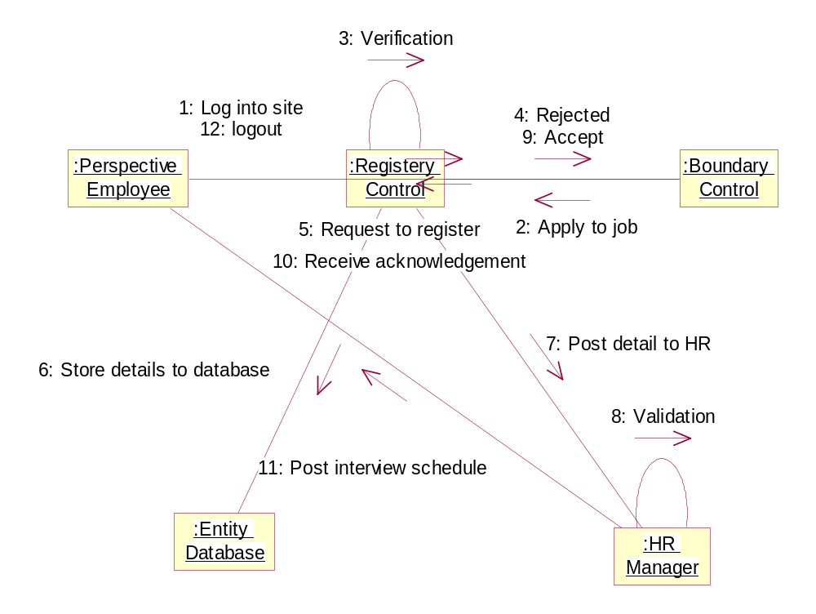

System ID feature | SF_E-Induction_PE_04
Requirement id | EIS_PersEmp_UC_05
Actor | Perspective Employee
Business Logic | 1.View job details  2.Clicks on apply button  3.Receive interview schedule
Client side validation | Required fields of the applicant validation
Server side validation | 1. checks the applicant registered  2. Interview schedule checks for updation  3. Filter applicants  4. Post updated interview schedule  5. Checks the applicant suitable for applied job

Sequence Diagram
Receive Offer Letter
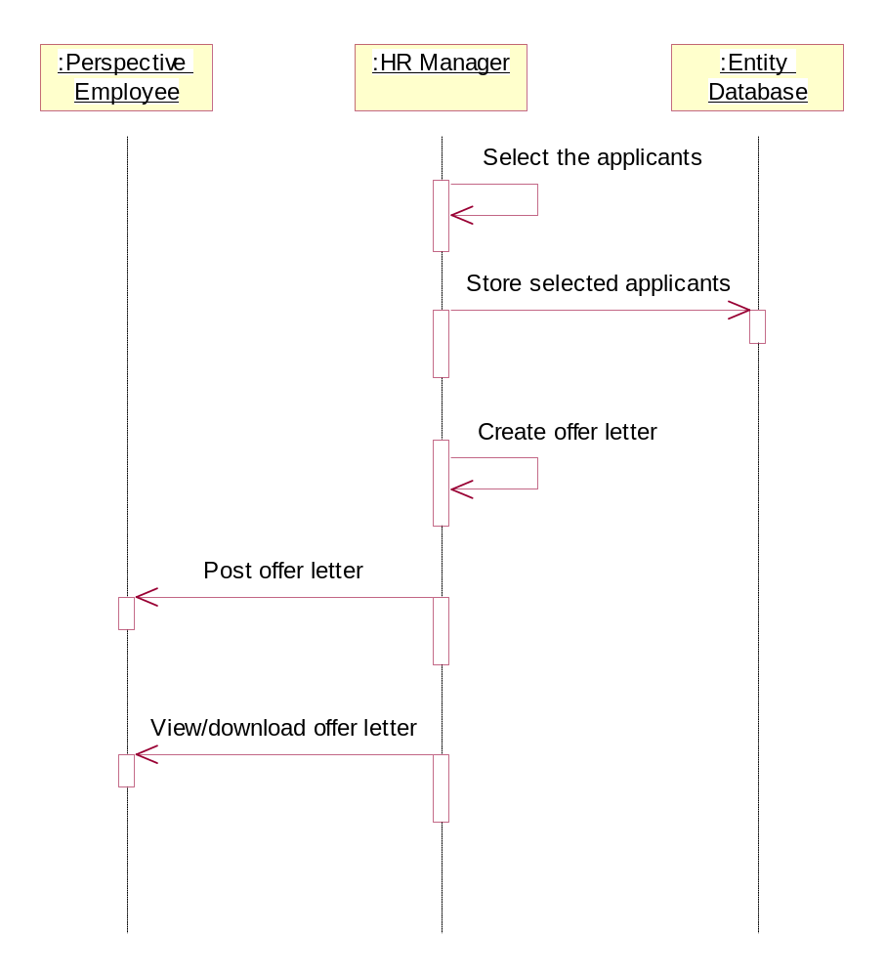

Collaboration Diagram

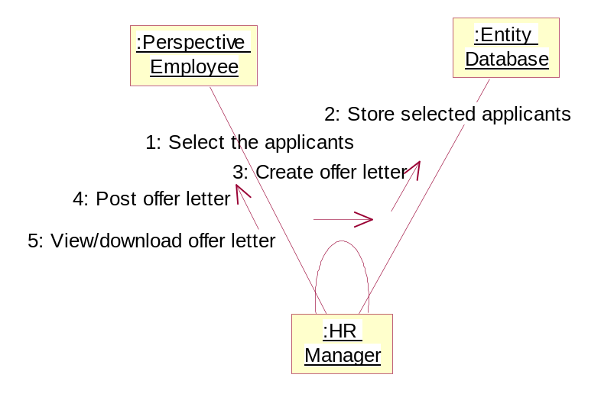

System Id Feature | SF_E-Induction_PE_05
Requirement ID | EIS_PersEmp_UC_08
Actor | Perspective Employee
Business logic | 1. Receive mail  2.Clicks on download offer letter  3.View offer letter
Client side | NA
Server side | NA

HR Manager
Sequence Diagram
- View the list of applicants
- Post interview schedule

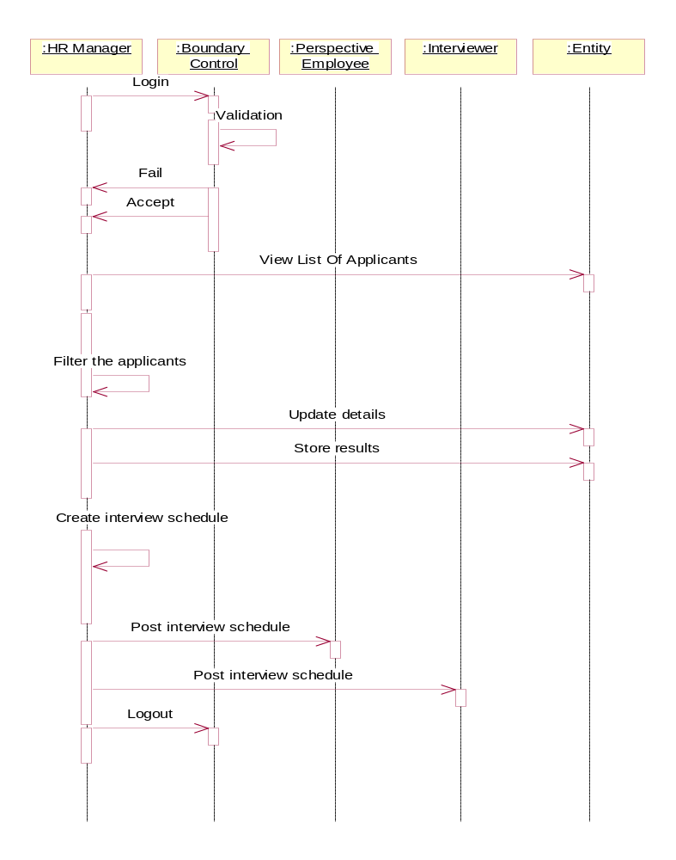

Collaboration Diagram

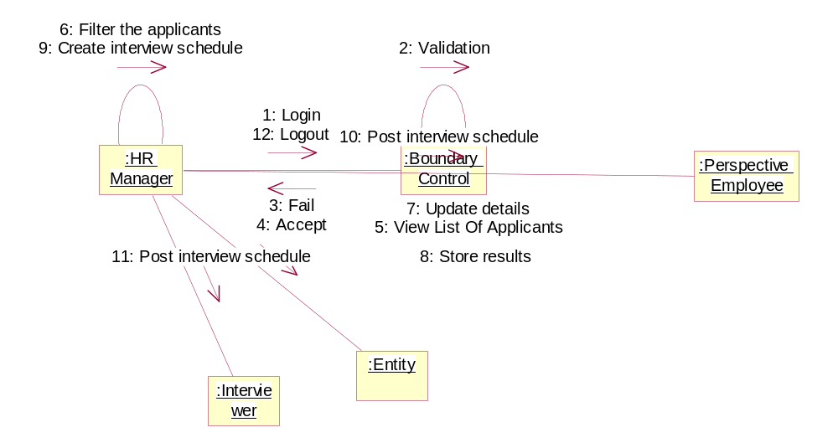

System Id Feature | SF_E-Induction HR Manager_01
Requirement ID | EIS_HR MANAGER_UC_02
Actor | HR Manager
Business logic | 1.Receive Applicant mail  2.Filter applicants  3.Create/Update interview schedule  4.Post interview schedule to PE and Interviewer
Client side Validation | 1.Filter under requirements  2.Checks the interview schedule
Server side | 1.Interview schedule is updated or not  2.Store applicant details

Select Status of Applicant

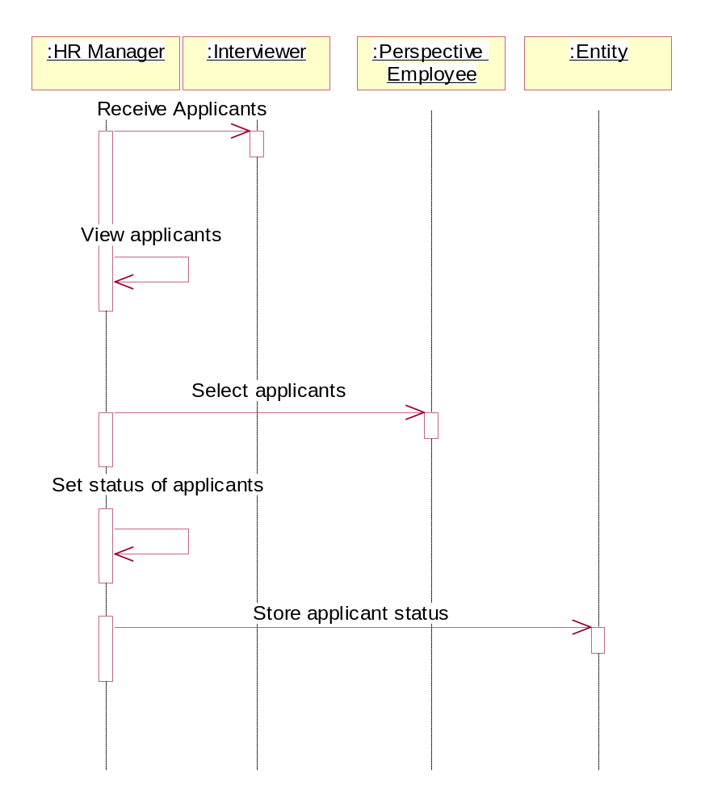

Collaboration Diagram
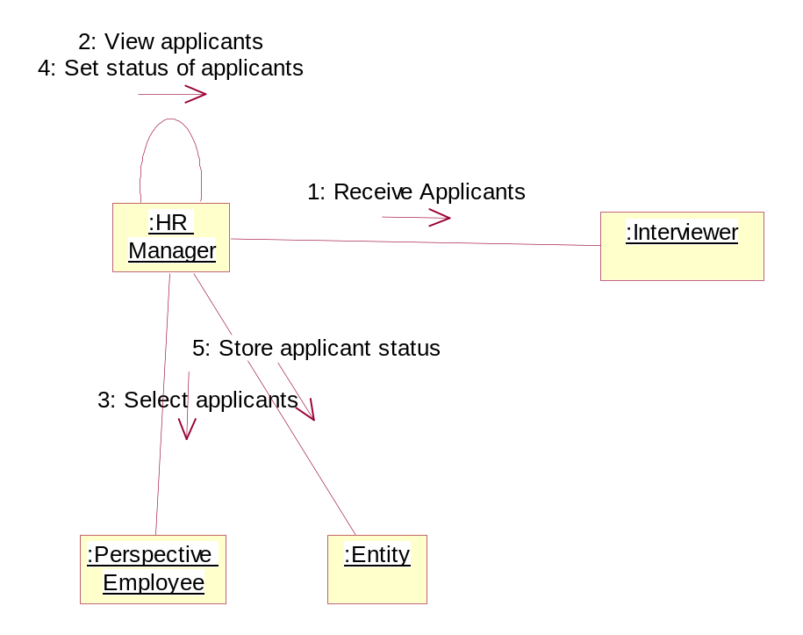

System Feature ID | SF_E-Induction HR Manager_02
Requirement ID | EIS_HR MANAGER_UC_03
Actor | HR Manager
Business logic | 1.Select applicant  2.filter the applicant  2.Set status of applicant
Client side Validation | Validate Posted resume
Server side | Store status of applicant

Interiviewer Module

Sequence Diagram

- Receive list of applicants
- Receive interview schedule

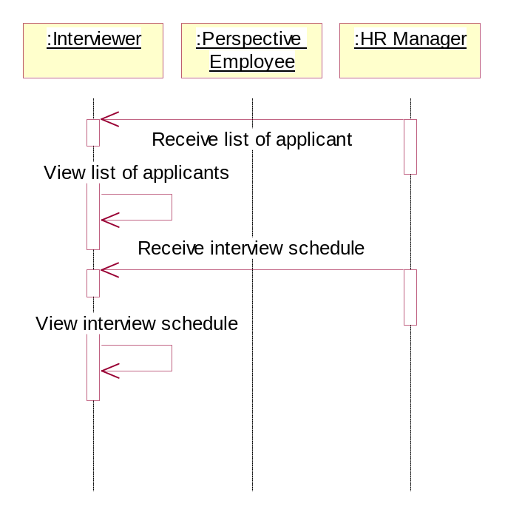
Collaboration Diagram
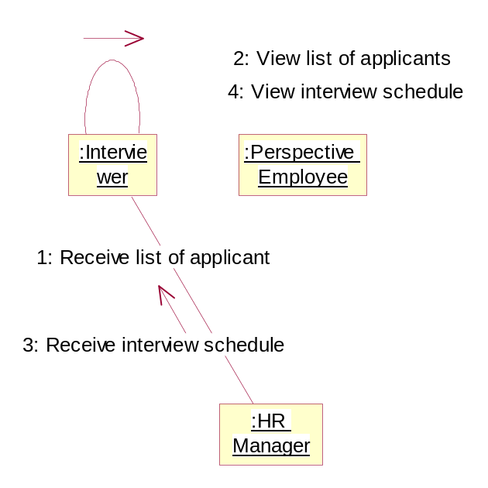

System Feature ID | SF_E-Induction _Interviewer_01
Requirement ID | EIS_INTERVIEWER_UC_02
Actor | HR Manager
Business logic | 1.receive list of applicants  2.receive interview schedule
Client side Validation | Check the received list is validated.  Check the received Schedule is updated.
Server side | Post schedule is checks for updation

Sequence Diagram
- Post feed back to HR Manager
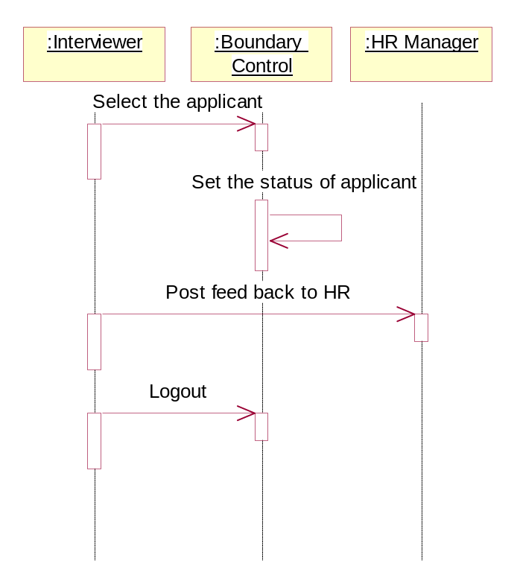

Collaboration Diagram
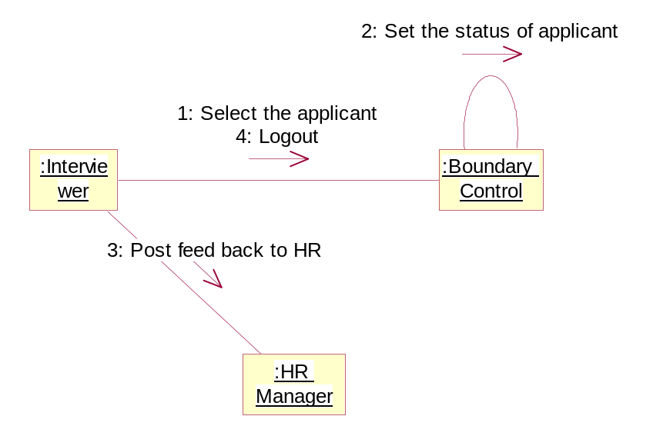

System Feature ID | SF_E-Induction _Interviewer_02
Requirement ID | EIS_INTERVIEWER_UC_05
Actor | HR Manager
Business logic | - set the status of the applicants  2. click on the post button
Client side Validation | Check for the set of status
Server side | Stored to database and views to the HR manager

Administrator
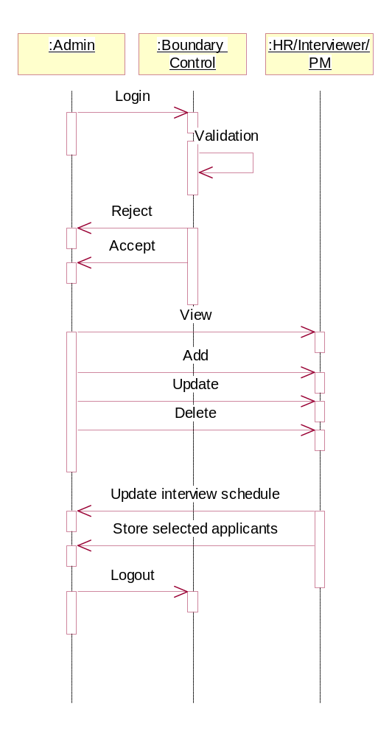

Collaboration Diagram
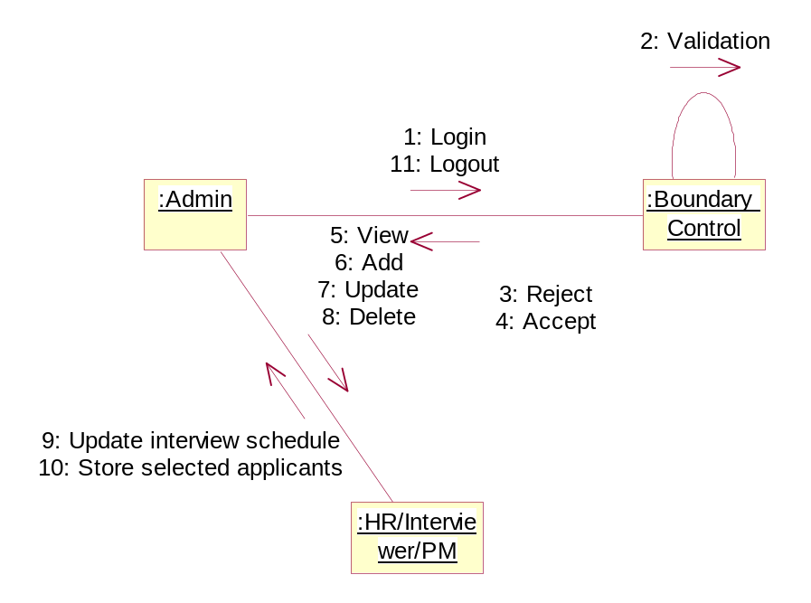

System Feature ID | SF_E-Induction _Admin_01
Requirement ID | EIS_Admin_UC_01(Add, Delete, Update, View)
Actor | Admin
Business logic | - log in to the system  - View the details of the HR, Interviewer, Project Manager, Perspective Employee.  - Add the HR, Interviewer, Project Manager, Perspective Employee.  - Delete the HR, Interviewer, Project Manager, Perspective Employee.  - Update the HR, Interviewer, Project Manager, Perspective Employee.
Client side Validation | Log in should validated
Server side | - Log in should be check for the comparison  - Operation results should be store to database

Data Dictionary

DATA DICTIONARY TABLES

Introduction to the Data Dictionary
One of the most important parts of an Oracle database is its data dictionary, which is a read-only set of tables that provides information about the database. A data dictionary contains:
- The definitions of all schema objects in the database (tables, views, indexes, clusters, synonyms, sequences, procedures, functions, packages, triggers, and so on)
- How much space has been allocated for, and is currently used by, the schema objects
- Default values for columns
- Integrity constraint information
- The names of Oracle users
- Privileges and roles each user has been granted
- Auditing information, such as who has accessed or updated various schema objects
- Other general database information
The data dictionary is structured in tables and views, just like other database data. All the data dictionary tables and views for a given database are stored in that database's SYSTEM table space.
Not only is the data dictionary central to every Oracle database, it is an important tool for all users, from end users to application designers and database administrators. Use SQL statements to access the data dictionary. Because the data dictionary is read-only, you can issue only queries (SELECT statements) against it's tables and views.

Structure of the Data Dictionary
The data dictionary consists of the following:

Base Tables
The underlying tables that store information about the associated database. Only Oracle should write to and read these tables. Users rarely access them directly because they are normalized, and most of the data is stored in a cryptic format.

User-Accessible Views
The views that summarize and display the information stored in the base tables of the data dictionary. These views decode the base table data into useful information, such as user or table names, using joins and WHERE clauses to simplify the information. Most users are given access to the views rather than the base tables.

SYS, Owner of the Data Dictionary
The Oracle user SYS owns all base tables and user-accessible views of the data dictionary. No Oracle user should ever alter (UPDATE, DELETE, or INSERT) any rows or schema objects contained in the SYS schema, because such activity can compromise data integrity. The security administrator must keep strict control of this central account.

How the Data Dictionary Is Used
The data dictionary has three primary uses:
- Oracle accesses the data dictionary to find information about users, schema objects, and storage structures.
- Oracle modifies the data dictionary every time that a data definition language (DDL) statement is issued.
- Any Oracle user can use the data dictionary as a read-only reference for information about the database.

How Oracle Uses the Data Dictionary
Data in the base tables of the data dictionary is necessary for Oracle to function. Therefore, only Oracle should write or change data dictionary information. Oracle provides scripts to modify the data dictionary tables when a database is upgraded or downgraded.
During database operation, Oracle reads the data dictionary to ascertain that schema objects exist and that users have proper access to them. Oracle also updates the data dictionary continuously to reflect changes in database structures, auditing, grants, and data.
For example, if user Kathy creates a table named parts, then new rows are added to the data dictionary that reflect the new table, columns, segment, extents, and the privileges that Kathy has on the table. This new information is then visible the next time the dictionary views are queried.

Public Synonyms for Data Dictionary Views
Oracle creates public synonyms for many data dictionary views so users can access them conveniently. The security administrator can also create additional public synonyms for schema objects that are used systemwide. Users should avoid naming their own schema objects with the same names as those used for public synonyms.

Cache the Data Dictionary for Fast Access
Much of the data dictionary information is kept in the SGA in the dictionary cache, because Oracle constantly accesses the data dictionary during database operation to validate user access and to verify the state of schema objects. All information is stored in memory using the least recently used (LRU) algorithm.
Parsing information is typically kept in the caches. The COMMENTS columns describing the tables and their columns are not cached unless they are accessed frequently.

Other Programs and the Data Dictionary
Other Oracle products can reference existing views and create additional data dictionary tables or views of their own. Application developers who write programs that refer to the data dictionary should refer to the public synonyms rather than the underlying tables: the synonyms are less likely to change between software releases.

How to Use the Data Dictionary
The views of the data dictionary serve as a reference for all database users. Access the data dictionary views with SQL statements. Some views are accessible to all Oracle users, and others are intended for database administrators only.
The data dictionary is always available when the database is open. It resides in the SYSTEM tablespace, which is always online.
The data dictionary consists of sets of views. In many cases, a set consists of three views containing similar information and distinguished from each other by their prefixes:

Table 4-1 Data Dictionary View Prefixes
Prefix | Scope
USER | User's view (what is in the user's schema)
ALL | Expanded user's view (what the user can access)
DBA | Database administrator's view (what is in all users' schemas)

The set of columns is identical across views, with these exceptions:
- Views with the prefix USER usually exclude the column OWNER. This column is implied in the USER views to be the user issuing the query.
- Some DBA views have additional columns containing information useful to the administrator.

Views with the Prefix USER
The views most likely to be of interest to typical database users are those with the prefix USER. These views:
- Refer to the user's own private environment in the database, including information about schema objects created by the user, grants made by the user, and so on
- Display only rows pertinent to the user
- Have columns identical to the other views, except that the column OWNER is implied
- Return a subset of the information in the ALL views
- Can have abbreviated PUBLIC synonyms for convenience
For example, the following query returns all the objects contained in your schema:
SELECT object_name, object_type FROM USER_OBJECTS;

Views with the Prefix ALL
Views with the prefix ALL refer to the user's overall perspective of the database. These views return information about schema objects to which the user has access through public or explicit grants of privileges and roles, in addition to schema objects that the user owns. For example, the following query returns information about all the objects to which you have access:
SELECT owner, object_name, object_type FROM ALL_OBJECTS;

Views with the Prefix DBA
Views with the prefix DBA show a global view of the entire database. Synonyms are not created for these views, because DBA views should be queried only by administrators. Therefore, to query the DBA views, administrators must prefix the view name with its owner, SYS, as in the following:
SELECT owner, object_name, object_type FROM SYS.DBA_OBJECTS;

Oracle recommends that you implement data dictionary protection to prevent users having the ANY system privileges from using such privileges on the data dictionary. If you enable dictionary protection (O7_DICTIONARY_ACCESSIBILITY is false), then access to objects in the SYS schema (dictionary objects) is restricted to users with the SYS schema. These users are SYS and those who connect as SYSDBA.

The DUAL Table
The table named DUAL is a small table in the data dictionary that Oracle and user-written programs can reference to guarantee a known result. This table has one column called DUMMY and one row containing the value X.

Dynamic Performance Tables
Throughout its operation, Oracle maintains a set of virtual tables that record current database activity. These tables are called dynamic performance tables.
Dynamic performance tables are not true tables, and they should not be accessed by most users. However, database administrators can query and create views on the tables and grant access to those views to other users. These views are sometimes called fixed views because they cannot be altered or removed by the database administrator.
SYS owns the dynamic performance tables; their names all begin with V_$. Views are created on these tables, and then public synonyms are created for the views. The synonym names begin with V$. For example, the V$DATAFILE view contains information about the database's data files, and the V$FIXED_TABLE view contains information about all of the dynamic performance tables and views in the database.

Database Object Metadata
The DBMS_METADATA package provides interfaces for extracting complete definitions of database objects. The definitions can be expressed either as XML or as SQL DDL. Two styles of interface are provided:
- A flexible, sophisticated interface for programmatic control
- A simplified interface for ad hoc querying
REGISTRATION DETAILS

S.No: | COLOUMN NAME | DATA TYPE | Constraint | Remarks
1 | First name | Varchar(50) | Not null
2 | Last name | Varchar(50) | Null
3 | user id | Varchar(70) | Unique
4 | Password | Varchar(50) | Not null
5 | Gender | Varchar(6) | Not null
6 | cid | Varchar(8) | Primary key

PERSONAL DETAILS

S.No: | COLOUMN NAME | DATA TYPE | Constraint | Remarks
address | Address | Varchar(100) | Not null
City | City | Varchar(30) | Not null
state | State | Varchar(30) | Not null
country | Country | Varchar(25) | Not null
contact1 | Contact1 | Longint(15) | Not null
contact2 | Contact2 | Longint(15) | Null
Pid | Pid | Varchar(8) | Primary key
cid | cid | Varchar(8) | Foreign key
Dob | Dob | Datetime | Not null

EDUCATIONAL DETAILS

S.No: | COLOUMN NAME | DATA TYPE | Constraint | Remarks
1 | Edu id | Varchar(8) | Primary key
2 | primary higher edu | Varchar(50) | Not null
3 | Passed out | date time | Not null
4 | Secondary edu | Varchar(50) | Not null
5 | Passed out | date time | Not null
6 | Primary percentage | Decimal(10) | Not null
7 | Secondary | Decimal(10) | Not null
8 | Any diploma | Varchar(50) | Null
9 | primary university | Varchar(50) | Not null
10 | secondary university | Varchar(50) | Not null
11 | cid | Varchar() | Foreign key
12 | known language | Varchar(50) | Not null

EXPERIENCE DETAILS

S.No: | COLOUMN NAME | DATA TYPE | Constraint | Remarks
1 | cid | Varchar(8) | Foreign key
2 | company name | Varchar(50) | Not null
3 | Empid | Varchar(8) | Primary key
4 | Empdesignation | Varchar(25) | Not null
5 | join date | date time | Not null
6 | Reviel date | date time | Not null
7 | Sal(per annum) | Decimal(10) | Not null
8 | Reason to reviel | Varchar(50) | Not null

OTHER DETAILS

S.No: | COLOUMN NAME | DATA TYPE | Constraint | Remarks
1 | Oid | Varchar(8) | Primary key
2 | cid | Varchar(8) | Foreign key
3 | passport no | Varchar(25) | Unique
4 | pan card | Longint(25) | Unique
5 | election card id | Varchar(25) | unique

JOB DETAILS TABLE

S.No: | COLOUMN NAME | DATA TYPE | Constraint | Remarks
1 | job id | Longint | Primary key | Yes
2 | Job function | Varchar(100) | Not null | No
3 | Description | Varchar(100) | Not null | Yes
4 | Location | Varchar(50) | Not null | No
5 | Requirements | Varchar(100) | Not null | No
6 | Eligibility | Varchar(25) | Not null | No
7 | Experience | Varchar(15) | Null | No
8 | Key skills | Varchar(25) | Null | No
9 | company name | Varchar(50) | Not null | No
10 | Level | Varchar(10) | Null | No
11 | Salary | Decimal(8) | Null | no
12 | cid | Varchar(8) | Foreign key | yes

INTERVIEW SCHEDULE TABLE

S.No: | COLOUMN NAME | DATA TYPE | Constraint | Remarks
1 | interview id | Varchar(8) | Unique
2 | Interview type | Varchar(25) | Null
3 | interview start date | date time | Not null
4 | interview end date | date time | Not null
5 | Interview time | date time | Not null
6 | Place | Varchar(25) | Not null
7 | Location | Varchar(25) | Not null
8 | Interview mod 1 | Varchar(25) | Null
9 | cid | Varchar(8) | Foreign key

EMPLOYEE TABLE

S.No: | COLOUMN NAME | DATA TYPE | Constraint | Remarks
1 | Emp id | Varchar | Primary key
2 | emp name | Varchar(50) | Not null
3 | Designation | Varchar(35) | Not null
4 | Address 1 | Varchar(50) | Not null
5 | Address 2 | Varchar(50) | Null
6 | contact 1 | Longint(15) | Not null
7 | contact 2 | Longint(15) | Null
8 | dept id | Longint(8) | Not null
9 | dept name | Varchar(50) | Not null
10 | branch location | Varchar(50) | Not null
11 | Cid | Varchar | Foreign key

HR Manager TABLE

S.No: | COLOUMN NAME | DATA TYPE | Constraint | Remarks
1 | HRId | Varchar | Primary key
2 | name | Varchar(50) | Not null
3 | Address 1 | Varchar(50) | Not null
4 | contact 1 | Longint(15) | Not null
5 | dept id | Longint(8) | Not null
6 | dept name | Varchar(50) | Not null
7 | branch location | Varchar(50) | Not null
8 | lid | Varchar | Foreign key

PM Manager TABLE

S.No: | COLOUMN NAME | DATA TYPE | Constraint | Remarks
1 | pid | Varchar | Primary key
2 | name | Varchar(50) | Not null
3 | Address 1 | Varchar(50) | Not null
4 | contact 1 | Longint(15) | Not null
5 | dept id | Longint(8) | Not null
6 | dept name | Varchar(50) | Not null
7 | branch location | Varchar(50) | Not null
8 | lid | Varchar | Foreign key

Interviewer table

S.No: | COLOUMN NAME | DATA TYPE | Constraint | Remarks
1 | iid | Varchar | Primary key
2 | name | Varchar(50) | Not null
3 | Address 1 | Varchar(50) | Not null
4 | contact 1 | Longint(15) | Not null
5 | dept id | Longint(8) | Not null
6 | dept name | Varchar(50) | Not null
7 | branch location | Varchar(50) | Not null
8 | lid | Varchar | Foreign key

Component Diagram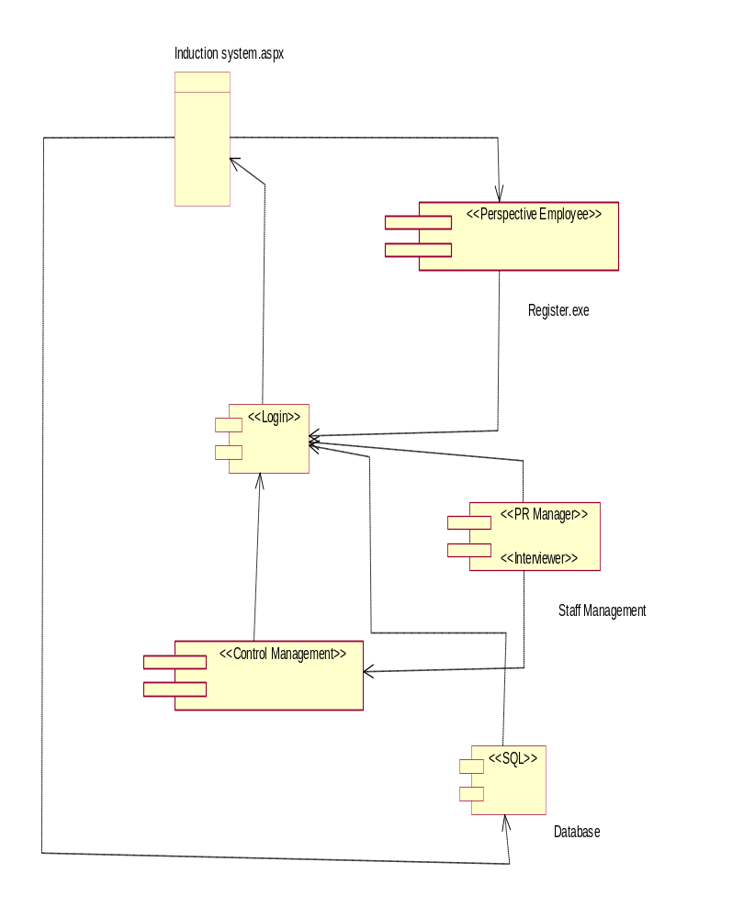

Class Diagrams

User Interface Design

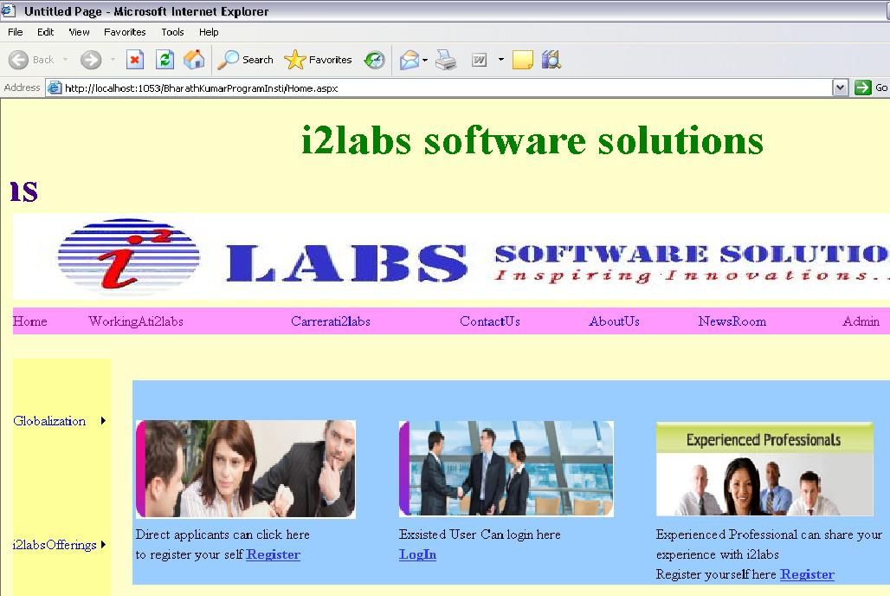
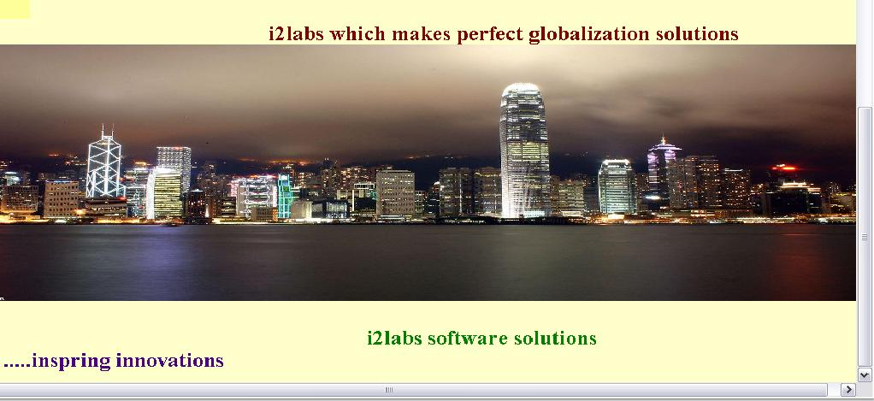

Register Page

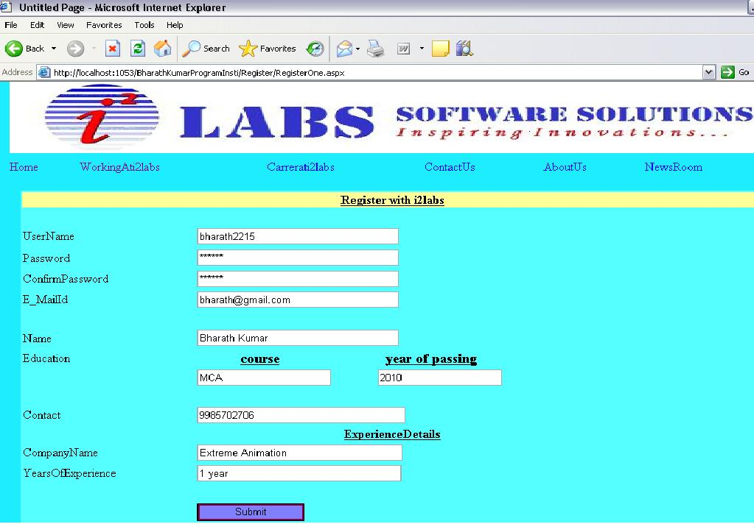

Login Page

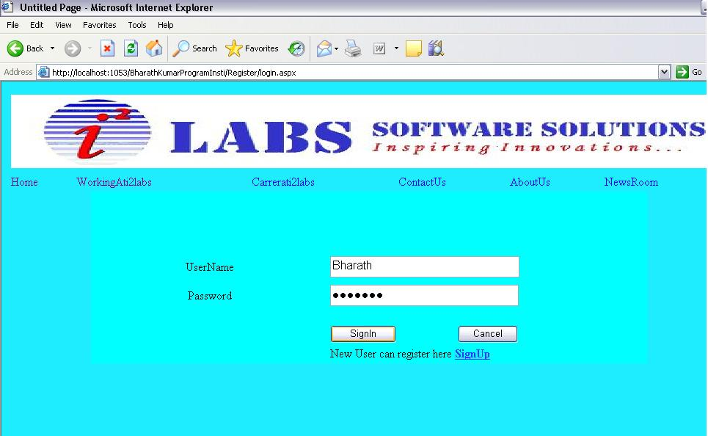

View List of Applicants

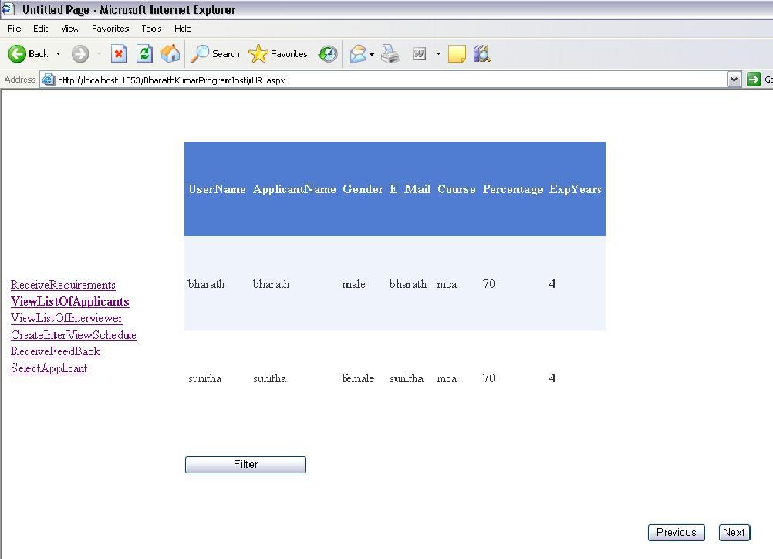

View List of Interviewer

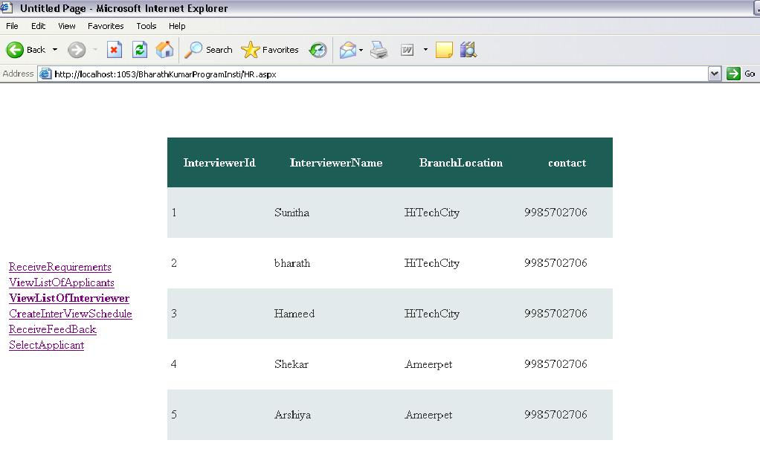

View and Create Interview Schedule

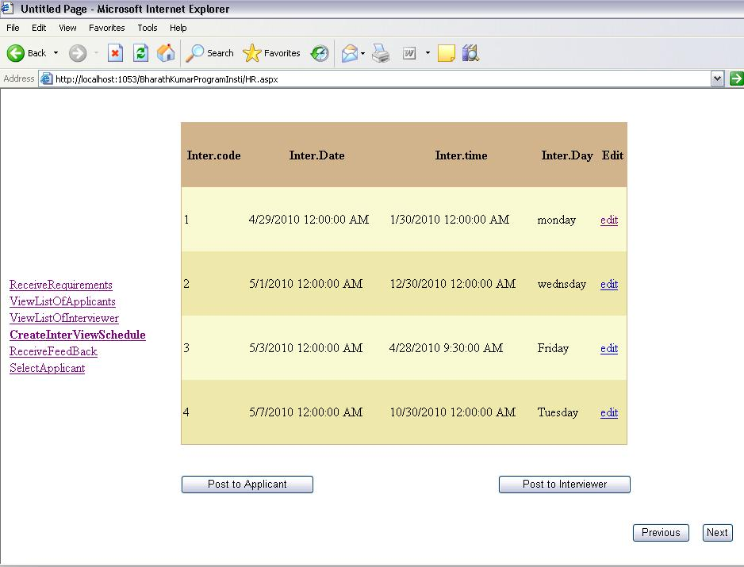

View Interview Schedule

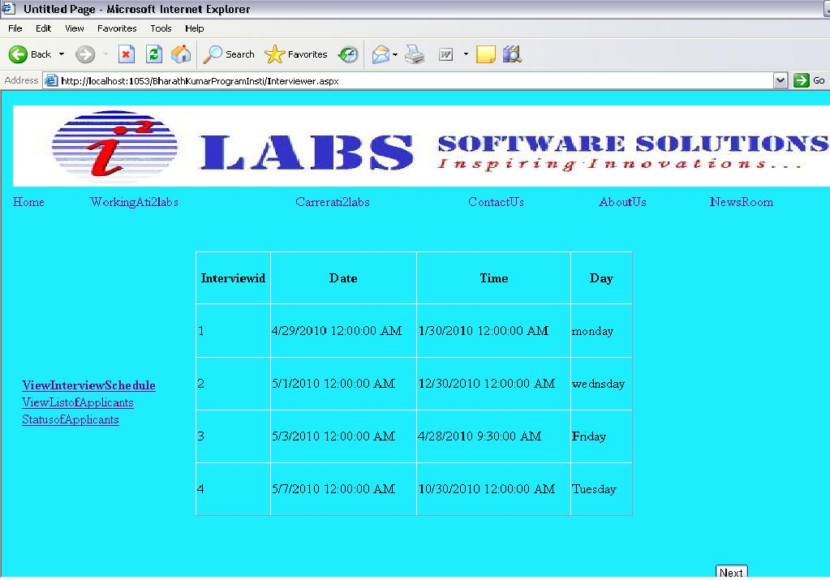

Modify Applicant Details

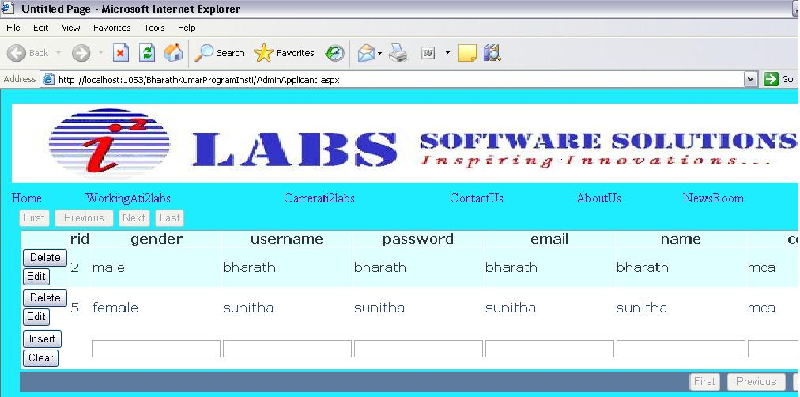

Modify Interviewer Details

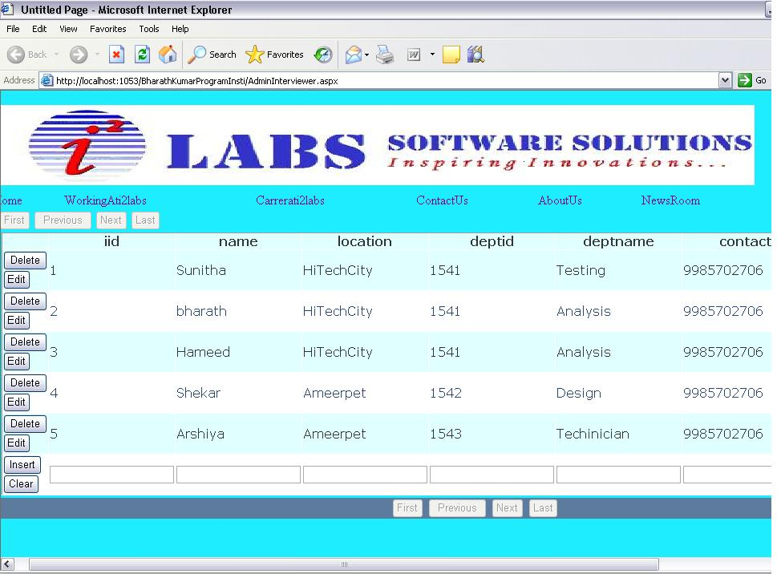

Modify HR Manager Details
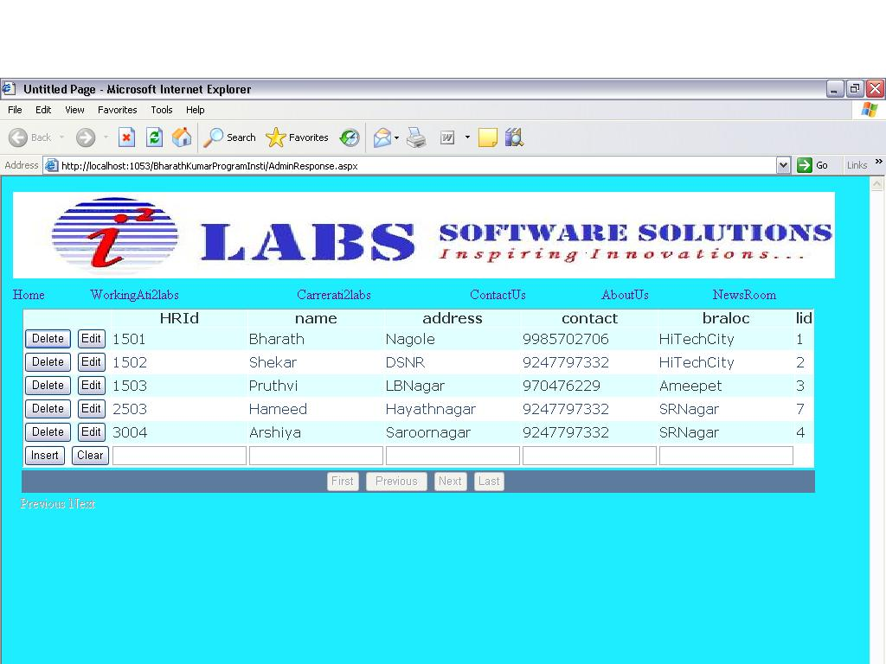

Modify Project Manager Details

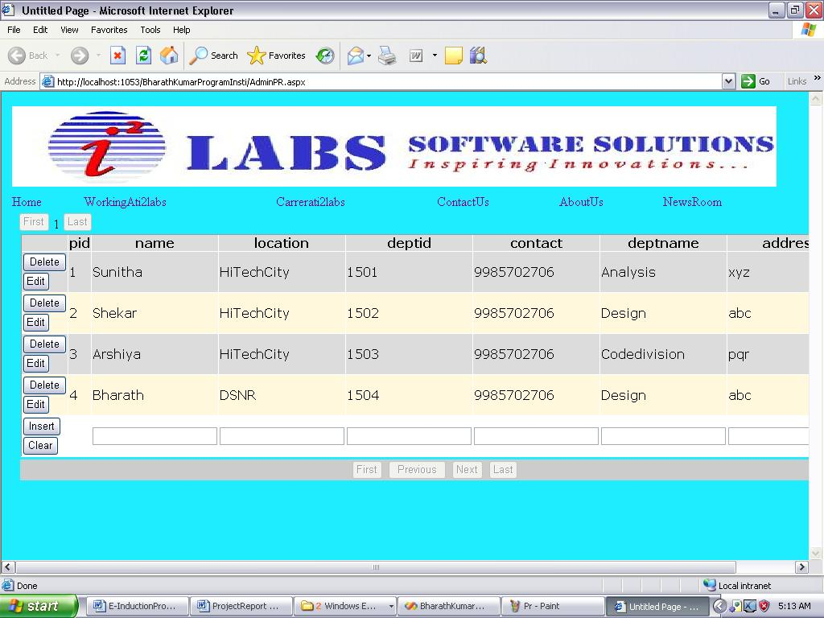

Working at i2labs

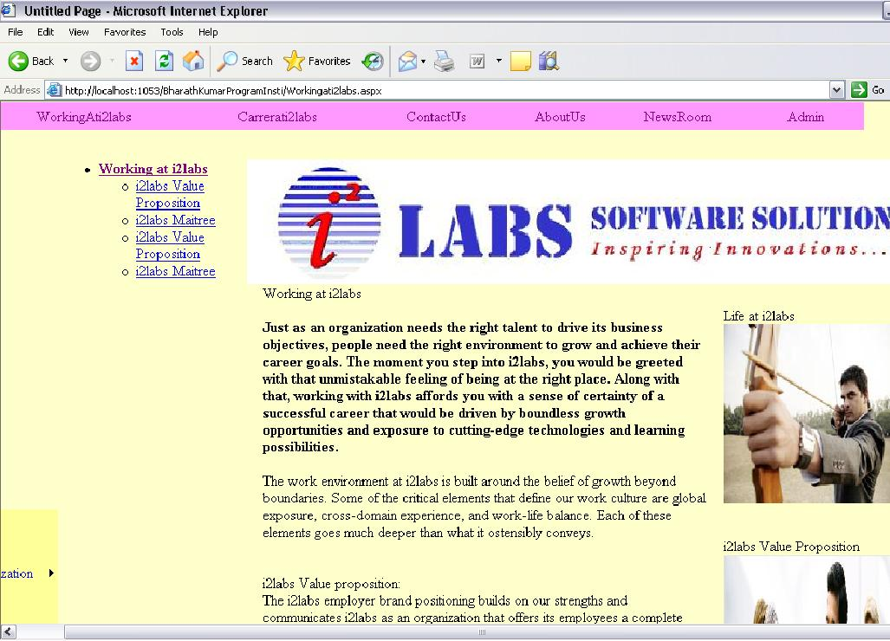

Coding

.NET Framework

The Microsoft.NET strategy was presented by Microsoft officials to the rest of the world in June 2000:

- .NET is Microsoft's new Internet and Web strategy
- .NET is NOT a new operating system
- .NET is a new Internet and Web based infrastructure
- .NET delivers software as Web Services
- .NET is a framework for universal services
- .NET is a server centric computing model
- .NET will run in any browser on any platform
- .NET is based on the newest Web standards

.NET Internet Standards

.NET is built on the following Internet standards:

- HTTP, the communication protocol between Internet Applications
- XML, the format for exchanging data between Internet Applications
- SOAP, the standard format for requesting Web Services
- UDDI, the standard to search and discover Web Services

.NET Framework

- The .NET Framework is the infrastructure for the new Microsoft .NET Platform.

- The .NET Framework is a common environment for building, deploying, and running Web Services and Web Applications.

- The .NET Framework contains common class libraries - like ADO.NET, ASP.NET and Windows Forms - to provide advanced standard services that can be integrated into a variety of computer systems.

- The .NET Framework is language neutral. Currently it supports C++, C#, Visual Basic, and JScript (The Microsoft version of JavaScript). Third-party languages like COBOL, Eiffel, Perl, Python, Smalltalk, and others - will also be available for building future .NET Framework applications. The new Visual Studio.NET is a common development environment for the new .NET Framework. It provides a feature-rich application execution environment, simplified development and easy integration between a numbers of different development languages.

Active Server Pages - ASP.NET

ASP.NET is the latest version of ASP. It includes Web Services to link
Applications, services and devices using HTTP, HTML, XML and SOAP.

New in ASP.NET:

- New Language Support
- Programmable Controls
- Event Driven Programming
- XML Based Components
- User Authentication
- User Accounts and Roles
- High Scalability
- Compiled Code
- Easy Configuration
- Easy Deployment
- Not ASP Compatible
- Includes ADO.NET

SQL Server 2000
SQL Server 2000 is a fully web-enabled database.
SQL Server 2000 has strong support for XML and HTTP which are two of the main infrastructure technologies for .NET.
Some of the most important new SQL Server features are direct access to the
database from a browser, query of relational data with results returned as XML,
as well as storage of XML in relational formats.

Internet Information Server 6.0
IIS 6.0 has strong support for more programming to take place on the server, to
Allow the new Web Applications to run in any browser on any platform.

.NET Web Services:
Web services are small units of code built to handle a limited task.

What are Web Services?
- Web services are small units of code
- Web services are designed to handle a limited set of tasks
- Web services uses XML based communicating protocols
- Web services are independent of operating systems
- Web services are independent of programming languages
- Web services connect people, systems and devices

Small Units of Code
Web services are small units of code designed to handle a limited set of tasks.
An example of a web service can be a small program designed to supply other
applications with the latest stock exchange prices. Another example can be a
small program designed to handle credit card payment.

SQL SERVER

Editions of sql server

• Enterprise (Developer)

• Standard

• Personal

Components

• Server Components

• Components

Server Components

• SQL Server Engine

• SQL Server Agent

• Distributed Transaction Coordinator (DTC)

• Microsoft Search Engine

• SQL Mail

• English Query

• Data Transformation Services (DTS)

• Analysis Services

SQL Server Engine

• The core of SQL Server.

• It is the process that handles all the relational database work.

• SQL language describes engine only the query to be processed.

• Query optimizer determines how to process the query based on the costs of different types of query execution operations.

SQL Server Agent

• It is an optional process which, when running, executes the SQL jobs and handles other automated tasks.

Distributed Transaction Coordinator (DTC)

• It is a process that handles dual phase commits for transactions that span multiple SQL Servers.

Data Transformation Services (DTS)

• It moves data among nearly any types of data sources.

• DTS is extremely useful during data conversions, collecting data from many dissimilar data sources, or gathering for data warehousing.

• Analysis Services

• It enables the developer to define cubes that are similar to excel pivot tables or Access cross tab queries.

Client Components

• Server Network Utility

• Client Network Utility

• SQL Server Service Manager

• Enterprise Manager

• Query Analyzer .Etc
Server Network Utility

• It configures the way in which SQL Server communicates with clients.

• Technically this is a client component used to control the server.

Client Network Utility

• It is the client side partner to the Server Network Utility.

• It establishes the protocols used to communicate from the client to server.

Service Manager

• A client utility to start and stop the major services of SQL Server and to indicate the current status.

Enterprise Manager

• It is used for administrative tasks.

• An interface for database diagrams.

Query Analyzer

• The tool for executing raw batches of T-SQL code.

• Editing, executing and saving scripts of code is what Query Analyzer does best.

• Also in viewing query-optimization plans and execution statistics.

Administering SQL Server

Administering SQL Server

Server-Configuration Properties:

It enables to set server-wide performance and display properties in SQL Server.

Default Message Language :-

The default language for server user messages can be set in Enterprise Manager as well as in code

Full-Text Search Default Language:-

The default language for full-text searches can only be set from within code

Query Governor Cost Limit:-

It limits the maximum number of queries SQL Server will perform according to the estimated query cost. If the user submits a query that exceeds the limit set by the query governor, SQL Server will not execute the query.

Server Security:

SQL Server uses a two-phase security authentication scheme. The user is first authenticated to the SQL server. Once the user is “in” the server, access can be granted to the individual databases.

SQL Server stores all login information within the master database.

SQL Server Authentication Mode:-

When SQL Server was installed, one of the decisions made was which of the following authentication methods was used:

Windows authentication mode-windows authentication only.

Mixed mode-both windows authentication and SQL Server user authentication.

Windows Authentication:-

It is superior to mixed mode because the user does not need to learn yet another password.

The use of windows authentication means that users exist as windows users to be recognized by SQL Server. The windows SID(Security Identifier) is passed from windows to SQL Server.

It is very robust that it will authenticate not only windows users, but also users within windows user groups.

When a windows group is accepted as a SQL Server login, any windows user who is a member of the group can be authenticated by SQL Server. Access, roles and permissions can be assigned for the windows group; they will apply to any windows user in the group.

Unified Modeling Language:

Identifiable object-oriented modeling languages began to appear between mid-1970 and the late 1980s as various methodologists experimented with different approaches to object-oriented analysis and design. The number of identified modeling languages increased from less than 10 to more than 50 during the period between 1989-1994. Many users of OO methods had trouble finding complete satisfaction in any one modeling language, fueling the "method wars.
The development of UML began in late 1994 when Grady Booch and Jim Rum Baugh of Rational Software Corporation began their work on unifying the Booch and OMT (Object Modeling Technique) methods

During 1996, it became clear that several organizations saw UML as strategic to their business. A Request for Proposal (RFP) issued by the Object Management Group (OMG) provided the catalyst for these organizations to join forces around producing a joint RFP response. Rational established the UML Partners consortium with several organizations willing to dedicate resources to work toward a strong UML 1.0 definition.

The Unified Modeling Language allows the software engineer to express an analysis model using the modeling notation that is governed by a set of syntactic semantic and pragmatic rules.

Relationships
Association
A semantic connection between two instances
Generalization
A relationship between an element and the sub elements that may be substituted for it
Dependency
The use of one element by another
Refinement
A shift in levels of abstraction

A UML system is represented using five different views that describe the system from distinctly different perspective. Each view is defined by a set of diagram, which is as follows.

User Model View

- This view represents the system from the users perspective.
- The analysis representation describes a usage scenario from the end- user perspective.

Structural model view
- In this model the data and functionality are arrived from inside the system.
- This model view models the static structures.

Behavioral Model View
It represents the dynamic of behavioral as parts of the system, depicting the interactions of collection between various structural elements described in the user model and structural model view.

Implementation Model View
In this the structural and behavioral as parts of the system are represented as they are to be built.

UML diagrams :

Structural Diagrams
A type of diagram that depicts the elements of a specification that are irrespective of time. This includes class, composite structure, component, deployment, object, and package diagrams.

Class diagram
Shows a collection of static model elements such as classes and types, their contents, and their relationships. Building blocks of the model: class & relationships

Object diagram
Depicts objects and their relationships at a point in time, typically a special case of either a class diagram or a communication diagram.

Package diagram
Shows how model elements are organized into packages as well as the dependencies between packages. Higher-level model organization

Behavioral Diagrams
A type of diagram that depicts behavioral features of a system or business process. This includes activity, state machine, and use case diagrams as well as the four interaction diagrams.

Use case diagram
External functionality of a system. Shows use cases, actors, and their interrelationships.

Sequence diagram
Models the sequential logic, in effect the time ordering of messages between classifiers. Time-ordered sequences of interacting objects

Collaboration diagram
Object-centered interaction of a society of objects

State transition diagram
Describes the states an object or interaction may be in, as well as the transitions between states. Formerly referred to as a state diagram, state chart diagram, or a state-transition diagram. The life history of a single object

Activity diagram
Depicts high-level business processes, including data flow, or to model the logic of complex logic within a system. Procedural flow of control within an overall interaction

Implementation Diagrams
Component diagram
Depicts the components that compose an application, system, or enterprise. The components, their interrelationships, interactions, and their public interfaces are depicted. The dependencies among software units

Deployment diagram
Shows the execution architecture of systems. This includes nodes, either hardware or software execution environments, as well as the middleware connecting them. The distribution and interaction of components and objects on computational nodes

Interaction diagrams: A subset of behavior diagrams which emphasize object interactions. This includes communication, interaction overview, sequence, and timing diagrams.

Advantages

- Provide users with a ready-to-use, expressive visual modeling language so they can develop and exchange meaningful models.
- Provide extensibility and specialization mechanisms to extend the core concepts.
- Be independent of particular programming languages and development processes.
- Provide a formal basis for understanding the modeling language.
- Encourage the growth of the OO tools market.
- Support higher-level development concepts such as collaborations, frameworks, patterns and components.
- Integrate best practices.

The UML is expressive
- The UML is applicable to a wide variety of problem domains and development processes
- The UML is stable

Test Cases

Registration

Test case ID | Input | Description | Expected result | Pass/Fail
EIS_TC_01 | Empty username, password, confirm password, address and contact number. | Empty username, password, confirm password, address and contact number given by user | Fields should not be empty | Pass
EIS_TC_02 | Invalid username and valid id, password, confirm password, address and contact number. | An Invalid username given by user | username field should be in specified format | Pass
EIS_TC_03 | Invalid username, password, confirm password, valid address and contact number. | An invalid username, password given by user | Username, password field should be in specified format. | Pass
EIS_TC_04 | Different password and confirm password provided. | Different password and confirm password provided by user. | Password mismatch | Pass
EIS_TC_05 | Invalid address and valid first name, last name, id, password, confirm password and contact number. | An invalid address provided by user. | Address field should be in specified format. | Pass
EIS_TC_06 | Invalid contact number and valid first name, last name, id, password, confirm password and address. | An invalid contact number provided by user. | Contact number field should be in specified format. | Pass
EIS_TC_07 | Valid first name, last name, id, password, confirm password, address and contact number. | Valid first name, last name, id, password, confirm password, address and contact number given by user. | Registration completed success fully | pass

Login by HR Manager

Test case ID | Input | Description | Expected result | Pass/Fail
EIS_TC_01 | Enter User id | Empty user id given by System user | User id field should not be empty | Pass
EIS _TC_02 | Enter Password | An empty field given by System user | Password field should not be empty | Pass

Login by Project Manager

Test case ID | Input | Description | Expected result | Pass/Fail
EIS_TC_01 | Enter User id | Empty user id given by System user | User id field should not be empty | Pass
EIS _TC_02 | Enter Password | An empty field given by System user | Password field should not be empty | Pass

Login by Interviewer

Test case ID | Input | Description | Expected result | Pass/Fail
EIS_TC_01 | Enter User id | Empty user id given by System user | User id field should not be empty | Pass
EIS _TC_02 | Enter Password | An empty field given by System user | Password field should not be empty | Pass

Login by Applicant

Test case ID | Input | Description | Expected result | Pass/Fail
EIS_TC_01 | Enter User id | Empty user id given by System user | User id field should not be empty | Pass
EIS _TC_02 | Enter Password | An empty field given by System user | Password field should not be empty | Pass

Login by Admin

Test case ID | Input | Description | Expected result | Pass/Fail
EIS_TC_01 | Enter User id | Empty user id given by System user | User id field should not be empty | Pass
EIS _TC_02 | Enter Password | An empty field given by System user | Password field should not be empty | Pass

Update employee profile

Test case ID | Input | Description | Expected result | Pass/Fail
EIS_TC_01 | Enter contact number | Empty contact given by System user | Id field should not be empty | Pass
EIS _TC_02 | Enter address of the employee | An empty field given by System user | Id field should not be empty | Pass
EIS _TC_03 | Enter the invalid contact | Number are entered by the employee is incorrect | Number should be valid | Pass

Update HR manager profile

Test case ID | Input | Description | Expected result | Pass/Fail
EIS_TC_01 | Enter contact number | Empty contact given by System user | Id field should not be empty | Pass
EIS _TC_02 | Enter address of the Hr manager | An empty field given by System user | Id field should not be empty | Pass
EIS _TC_03 | Enter the invalid contact | Number are entered by the HR manager is incorrect | Number should be valid | Pass

Update Project manager profile

Test case ID | Input | Description | Expected result | Pass/Fail
EIS_TC_01 | Enter contact number | Empty contact given by System user | Id field should not be empty | Pass
EIS _TC_02 | Enter address of the projectmanager | An empty field given by System user | Id field should not be empty | Pass
EIS _TC_03 | Enter the invalid contact | Number are entered by the project manager is incorrect | Number should be valid | Pass

Update Interviewer profile

Test case ID | Input | Description | Expected result | Pass/Fail
EIS_TC_01 | Enter contact number | Empty contact given by System user | Id field should not be empty | Pass
EIS _TC_02 | Enter address of the interviewer | An empty field given by System user | Id field should not be empty | Pass
EIS _TC_03 | Enter the invalid contact | Number are entered by the interviewer is incorrect | Number should be valid | Pass

Filter applicant profiles

Test case ID | Input | Description | Expected result | Pass/Fail
EIS_TC_01 | Select requirement, percentage | Empty Requirement, percentage | fields should not be empty | Pass
EIS _TC_02 | Valid requirement, invalid percentage | User selected invalid percentage | Percentage should be valid | Pass
EIS _TC_03 | Invalid requirement, valid percentage | User selected invalid requirement | Requirement should be valid | Pass

Conclusion

Future Enhancements

Bibliography

1. Dimensions of Formality: A Case Study for MKM in Software Engineering
Authors: Andrea Kohlhase, Michael Kohlhase, Christoph Lange

2. Title: Formal Proof of SCHUR Conjugate Function
Authors: Franck Butelle, Florent Hivert, Micaela Mayero, Frédéric Toumazet

3. Title: A Metrics Based Model for Understandability Quantification
Authors: Mohd Nazir, Raees A. Khan, Khurram Mus

4. Title: Maintainability Estimation Model for Object-Oriented Software in Design Phase
Authors: S. W. A. Rizvi, R. A. Khan

5. Title: An Object-Oriented Metamodel for Bunge-Wand-Weber Ontology
Authors: Arvind W. Kiwelekar, Rushikesh K. Joshi

6. Title: A Pedagogical Evaluation and Discussion about the Lack of Cohesion in Method
Metric Using Field Experiment
Authors: Ezekiel Okike

